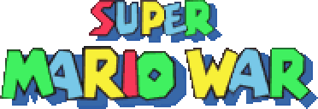
&
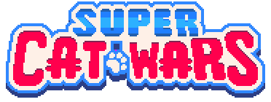
(UNOFFICIAL) Base Game Guide
Written by EleCyon
Original SMWar by 72dpiarmy (Full credits in next pages)

DISCLAIMER
SUPER MARIO WAR:
The game is created and developed by original developers Florian Hufsky & Michael Schaffer (Two52), and has assets contributed by members of the 72dpiarmy community. This game is intended as a tribute to Nintendo and to the original “Mario War” DOS fangame by Samuele Poletto, and for this purpose, it has been made non-commercial.
This game (nor any mods related to it), as well as its official source code, is completely free and downloadable from 72dpiarmy’s websites, and if you have bought the game from any other seller, you’ve been scammed! Please demand your money back if this happens.
If you liked Super Mario War, please don’t hesitate to also contribute to the 72dpiarmy community with new skins, maps, maybe even graphics packs and music packs.
Future versions/forks of SMWar and Super Cat Wars are now designed as a tribute to former developer Florian Hufsky (born 1986), who has passed away in 2009. Rest in peace, Flo. Your legacy shall live on in the community.
SUPER CAT WARS:
This mod is based on “Super Mario War” by 72dpiarmy (original developers Florian Hufsky and Two52), and is currently being developed by EleCyon, mmatyas, CindyChan, and various contributors to the mod. (Full credits listed below Disclaimer)
EleCyon does not own Super Mario War. All assets in Super Cat Wars are based on “Super Cat Tales” by Neutronized (Gionathan Pesaresi), with some based on “Dadish” & “Super Fowlst” by Thomas K. Young (the latter two are included just for fun, and also to match with the aesthetic of SCT). This mod is non-profit and was made just for fun. If you liked Super Cat Wars, please don’t hesitate to also check out Super Cat Tales, as well as Super Mario War. And maybe buy a Nintendo Switch, if you wanna support Nintendo and check out other official games in the Super Mario series.
A clarification on the presence of “Dadish” & “Super Fowlst 2” assets in SCW: I have decided to include these assets from Thomas K. Young’s more recent games in SCW solely for fun. These assets have been found to match the Super Cat Tales artstyle, and their SCW counterparts have been modified to use palettes and aesthetics that are within the SCT artstyle. However, I am aware of the controversy between Super Cat Tales & the Dadish games due to the fact they share a same artstyle and people are comparing the latter to SCT, which caused trouble for both sides. While these assets remain in the game, I want to clarify that these assets were added just for fun and to maximize diversity in aesthetics and player skins in SCW, and these assets were added with NO intention of any harm against Neutronized (Gionathan Pesaresi) or CatCup Games (Thomas K. Young) AND NO bias towards either developer. If you play SCW and spot any Dadish/Super Fowlst 2 assets in the game, PLEASE DO NOT bring up any sort of drama regarding the controversy between both developers and their respective games anywhere, as it will only lead to more trouble. Thank you.

CREDITS
SUPER MARIO WAR
Super Mario & all other related assets belong to Nintendo. This is a non-profit project.
CURRENT DEVELOPMENT TEAM (SMWar 2.0)
FORK, CODING, GITHUB REPOSITORY MANAGEMENT: mmatyas, AzureBerylBlue (Cat)
SDL MIXER X FORK: Wohlstand
BUG REPORTS: EleCyon, RazeZX
SUPER MARIO MAKER 2 SNES COVERS: Ladiesman217
ORIGINAL DEVELOPMENT TEAM (SMWar 1.8 Beta 2 & below)
DEVELOPMENT, CREATORS, CODING: Florian Hufsky & Two52
IDEAS, SUGGESTIONS, GRAPHICS: Jared
LINUX BUILD: Dolorous
CUSTOM GRAPHICS DESIGNER: Steven Graff
MACINTOSH BUILDS: Some Mac Guy
For the full credits, please see SMWar Special Thanks in the documentation folder (SCW), or “THANKS” in the SMWar 1.8 folder.
SUPER CAT WARS
Super Cat Tales and all other related assets belong to Neutronized/Gionathan Pesaresi. Music was composed by Rakugaki-otoko (DREAMSBELL), Dave Cowen, & FILIPPO.
Dadish/Super Fowlst belongs to Thomas K. Young. Kirby, Part Time UFO, & BOXBOY! belong to HAL Laboratory & Nintendo. Super Mario and all other related assets belong to Nintendo.
Super Cat Wars is based on SMWar 2.0, a fork of Super Mario War 1.8 Beta 2 developed by mmatyas.
PROJECT LEAD (GFX, audio, skins, maps): EleCyon
DOCUMENTATION: EleCyon, guided by the original SMWar 1.8 Readme
CUSTOM SCW BUILDS, TEXT STRING CHANGES, BUG FIXES: AzureBerylBlue (Cat), mmatyas
MUSIC COMPOSERS (Story Mode): DonnieTheGuy, Wowymolly, EleCyon, RazeZX
IDEAS, ADDITIONAL GRAPHICS, TILESETS: CindyChan, French Lamp Moth, Mr. GreenMan
COMMUNITY CONTRIBUTORS (Maps & Skins): Mr. GreenMan, Chips The Cat, RazeZX, TheDream64, Bench-kun, AzureBerylBlue (Cat), ToppatClan Cat (ReallyCool Artist/LD), Procatgamer, SLKitten, Akthecat
ADDITIONAL SOUNDTRACK CREDITS: undefinied3, MidiGuy, Light MetaS, nicetas_c, Koji Kondo, Nameless, ThinkOneMoreTime
SPECIAL THANKS: Team Gamble, r/Kirby, Super Cat Tales Discord, Neutronized, MegaStrimp, 1up World, 72dpiarmy, all my friends, my mom (who has found the game and downloaded it for me), and to all my fellow teammates, friends, and contributors. And especially to YOU!
Introduction
Welcome to Super Cat Wars / Super Mario War!
This is the Base Game Guide, where it features extensive documentation on various parts of the game (not counting the Level Editor, World Editor, and Online Multiplayer, which are covered in other guides in the Documentation folder of Super Cat Wars). This includes game options, mode settings, blocks, and items.
This manual, while based on Super Mario War 2.0 (mmatyas’ build) and Super Cat Wars, is designed to be backwards-compatible with the original Super Mario War 1.8 Beta 2, which is the last official version of the game that was made as Florian Hufsky (the original developer) passed away in 2009, and Two52 (co-developer) stopped working on the original game.
As this manual was designed for Super Cat Wars, various terminologies for assets in Super Cat Wars take top priority, which are mostly taken from Super Cat Tales and other Neutronized games (Some names are conjectural!). For backwards compatibility, the original Super Mario-related names for the items are added, with some using the present names of the items as seen in modern games such as Super Mario Maker 2 and Super Mario 3D World. Some names were retained from the original Super Mario War, as not much has changed in some items or content.
THE HISTORY OF SMWAR AND SCW
Super Mario War was originally developed by Florian Hufsky & Michael Schaffer (Two52) from 2006-2009, with contributions by 72dpiarmy’s community. This game was designed as an expanded tribute to the Mario fangame “Mario War” by Samuele Poletto, which played in a similar fashion, as well as to the Super Mario series by Nintendo.
Some known versions of Super Mario War include 1.6, 1.7 April Fools Edition (featuring lots of secrets and new features), and 1.8 (which was canned after Beta 2). On December 17, 2009, during 1.8’s development, the 72dpiarmy community has announced the passing of Florian Hufsky, one of the main developers of SMWar, which brought sadness to the community.
After Florian Hufsky’s passing, Two52 and the rest of the 72dpiarmy community attempted to carry on SMWar’s development, but 1.8’s development was completely halted. In 2012, EON8ight and Big JM (JM Dragon) have started to rewrite Super Mario War in Java, which is called Super Mario War: Stomp Arena. It was released in an Alpha state for NCFC 2012 on November 6, 2012. However, no additional development updates were made to this game, which led to this project being completely abandoned.
In 2019, a rebranding project was planned for Super Mario War, which long-time SMWar fan and 72dpiarmy lurker EleCyon also contributed to for a bit. This rebrand planned to turn Super Mario War into a toy-themed battle game, to keep it safe if ever Nintendo decides to DMCA it in the future. Due to delays, the rebranding project has instantly died.
EleCyon’s perspective:
Super Cat Wars was my attempt at reviving the Super Mario War community, which has been long dead since the original game's development has slowed down to a halt, 11 years ago, after Florian Hufsky (the game's main developer) sadly passed away. Back in 2009-2010, I binged this game a lot after my mom found the game (at that time, the version was 1.7 April Fools Edition) while she was finding some Mario games for me to play. It was really fun, especially when the new 1.8 update was around the corner, and I was a lurker in the 72dpiarmy community, looking for some new tileset packs, skins, and maps to play around with.
But suddenly, things began to change when Florian passed away in 2009. Looking back, I was really heartbroken by the fact the whole community has fallen in a state of eternal slumber - the original SMWStuff was gone, many mods, skins, maps, and tilesets for the game have come to a halt, and attempts to revive it (including Super Mario War: Stomp Arena (Java rewrite of SMWar) and the possible rebranding of the game I participated in on the official Discord server) ended up being unsuccessful.
In 2019, I became immersed into the Super Cat Tales fandom. As you all know it, Super Cat Tales was an indie game series developed by NEUTRONIZED (main developer being Gionathan Pesaresi) for mobile devices using Adobe AIR & Starling. And at the same time, I felt like having the urge to play a fun, little, nostalgic game on my laptop again, which is Super Mario War. On May 17, 2019, I started remaking parts of Super Cat Tales stages into Super Mario War with its default tileset. The next day, I managed to make a playable Alex skin for Super Mario War and upload it to the new SMWStuff Reloaded. A few days later, I started work on a Super Cat Tales music pack for SMWar, and successfully imported some tilesets from the game (first being the Tin Army airship tileset) into the level editor.
Eventually, with some help from the Super Cat Tales fandom, CindyChan (modder for Super Mario: 4 Jugadores), AzureBerylBlue (Cat), mmatyas (fluffypillow), my mutuals, and my new buddies at 72dpiarmy's community, I turned the importation of different Super Cat Tales assets in Super Mario War into a full-fledged project! I've been working on it non-stop alongside with my Just Shapes & Beats comic trilogy for nearly two years, and it's grown into one of my biggest projects ever worked on, even through an entire pandemic.
Now, my current vision and mission for Super Cat Wars is to make it the biggest revival of Super Mario War, a game that was almost lost to time after the passing of one of its main developers. This will mean bringing in a brand new audience (especially from the Super Cat Tales fandom), while encouraging a lot of old-time fans to get back on track for skin and map making, as well as using a new engine forked by mmatyas and AzureBerylBlue that will fix all the bugs that were left behind in 1.8 Beta 2.
Additionally, I want to keep Super Mario War alive and still downloadable to this day, because it was one of those little fun games that I’ve played the heck out of thanks to my mom who knew my potential as a huge Super Mario fan in every aspect as a kid, and I want to keep playing it even after its time has passed. And I want to make it as a tribute to Florian Hufsky and Michael Schaffer (Two52), especially to Florian, who has passed away a long time ago, and I’m sure he will be happy in the afterlife, looking at Super Mario War being revived into something new.
At long last, on February 2022, Super Cat Wars has been fully completed and released to the public. I hope you enjoy our biggest tribute to one of the greatest Mario fangames of all time, developed by passionate developers especially Florian Hufsky, who has passed away a long time ago. May the legacy continue on, and I hope you all had fun. Special thanks to you all for supporting such an incredible journey!
Table of Contents
Side note: Press CTRL+F when reading this document to open up the Find tool and jump to a section of the manual quicker.
Introduction
History
Table of Contents (You are here)
What is Super Mario War?
Version Differences
SECTION 01 – Main Menu
SECTION 02 – Controls
SECTION 03 – Match Types
SUBSECTION 03.1 – Single Game
SUBSECTION 03.2 – Tournament
SUBSECTION 03.3 – Tour
SUBSECTION 03.4 – World
SUBSECTION 03.5 – Minigame
SECTION 04 – Team & Character Selection
SECTION 05 – Game Modes
SUBSECTION 05.1-05.25 – Game Mode descriptions. Type in a subsection number to check a gamemode’s description.
SECTION 06 – Special Blocks
SECTION 07 – Stage Hazards and Gimmicks
SECTION 08 – Items & Powerups
SUBSECTION 08.1 – Mode-exclusive Items
SECTION 09 – Options
SUBSECTION 09.1 – Gameplay Settings
SUBSECTION 09.2 – Team Settings
SUBSECTION 09.3 – Item Selection Settings
SUBSECTION 09.4 – Item Settings
SUBSECTION 09.5 – Weapons & Projectiles Settings
SUBSECTION 09.6 – Weapon Use Limits Settings
SUBSECTION 09.7 – Graphics Settings
SUBSECTION 09.8 – Eyecandy Settings
SUBSECTION 09.9 – Music & Sound Settings
SECTION 10 – Community Links
SECTION 11 – Frequently Asked Questions
Thank You For Reading!
------------------------------------------------------------------------------------
WHAT IS SUPER MARIO WAR?
Super Mario War is a team deathmatch game based on the Super Mario series of games. In this game, the main goal is to stomp on other players’ heads to make them lose lives, so you’ll become the last player standing. While this is the main goal of the game, players can also use other map objects like blocks, interactive map objects, moving platforms, and powerups to their advantage to score points and defeat other players.
Super Mario War features 21 additional gamemodes that can spice up the original gameplay. In these gamemodes, players score points by becoming a chicken, tagging players into Shy Guys, delivering the correct eggs to different Yoshis, and many more. There are also five Match Types to adapt the game to a tournament or a globetrotting setting, like Tournament and World Mode.
Super Mario War also features extensive custom content support through customizable graphics, menus, player skins, music packs, sound packs, custom maps, and worlds. Players can make full on graphic/music mods of the game, or can share maps and skins to the community.
The game is also open-source, with the source code publicly available at https://code.google.com/p/supermariowar/ (1.8 Beta 2), and a fork being developed by mmatyas (Fluffypillow) at https://github.com/mmatyas/supermariowar.
FEATURES:
- Up to four players deathmatch fun
- a whole bunch of game modes (22) (featuring Chicken, Domination, CTF, ...)
- Comes with a level editor - you can create your own maps...
- ... and a world editor for making custom worlds with maps bundled in them
- More fun than poking a monkey with a stick
- Fully customizable in terms of graphics, music, skins, maps, sounds, and more (see Section 10 of the Base Game Guide for more details)
- The whole source code of the game is available, for free
- uses SDL and is fully portable to windows, linux, mac, ...
- CPU Players
- will make you happy and gives you a fuzzy feeling
WHAT IS SUPER MARIO WAR 2.0?
Super Mario War 2.0 is a fork of Super Mario War developed by mmatyas (Fluffypillow). It builds on the original Super Mario War 1.8 Beta 2 source code with extra features like toggleable secret orbs, new music, extra game mode spawning speeds, and a screenshot feature for taking screenshots in-game.
The fork was developed with the initial goal of bringing network multiplayer (online netplay) to Super Mario War in mind. While netplay is working, there are limitations, and possible bugs and lag, so it must be used with caution.
NEW FEATURES:
- The game now runs on SDL2. Graphic display is cleaner and performance may be improved on future Windows versions like Windows 11.
- Various quality of life changes and additions, including the following:
  - Ability to cycle tile types backwards in Tile Mode by using the middle mouse button
  - Addition of the Flag Base & Race Goal hotkey (J) to the F1 Help menu in the level editor
  - Adding the ability to set Capture the Flag Base speeds to “-1” (stationary, no position changes) in-game and in the World Editor, outside of Tour Mode text files
  - Support for up to 32 moving platforms on a single map, taking advantage of an unseen limitation in the 1.8 map format (Compatible with legacy 1.8 versions)
  - Toggleable secret orbs, especially for those with epilepsy
  - Screenshot feature has been added to the main SMWar game outside of the level editor & world editor (press INSERT)
  - Better skin navigation (Up+Down to pick a random skin, hold Up or Down to scroll faster through skins)
  - Removal of the 72dpiarmy Presents & Contest Winners screen (which is extremely outdated anyway) to help boot up the game faster without pressing ENTER
  - Additional fast speed parameters for Stomp enemy spawning, Survival hazard speeds, and more (Troll your friends!)
- Partially working netplay support (EXPERIMENTAL). It works and lets you play SMWar with friends over the network, but it hasn’t been tested a lot, so expect bugs. Parsec is usually recommended for multiplayer.
- Audio engine upgraded to SDL Mixer X by Wohlstand (developer for PGE Moondust Editor, also notably used in SMBX2), which makes extra music support much more versatile, and adds support for playing SNES SPCs.
- More fun than poking a Hisstocrat with a stick
- New music, featuring the soundtrack of All-Stars Super Mario Bros., as well as extra SNES-styled compositions of the new level themes from Super Mario Maker 1 and 2 by Ladiesman217.
- Lots of bugfixes for the glitches & bugs that remained in 1.8 Beta 2, such as the infamous World Boss bug & the Shy Guy Tag score glitches.
WHAT IS SUPER CAT WARS?
Super Cat Wars is a full graphic and audio mod for Super Mario War being developed by EleCyon (Jaden1291 the Toad in the Super Mario fandom). The mod is based on the Super Cat Tales series of mobile indie games by developer Gionathan Pesaresi (NEUTRONIZED). The mod is set to feature loads of extensive tilesets, backgrounds, skins, and a whole lot more, with some contributions from the 72dpiarmy community and the Super Cat Tales community.
The initial goal of this mod was to make it a point of Super Mario War’s revival, with an all-new theme based on an indie game with a huge following, bringing in a new audience and seeing a potential upsurge for additional community skins, maps, and beyond. This mod also runs on SMWar 2.0, mmatyas’ fork of the original game, bringing in the extra features seen above.
The game also features its very own Story Mode, playable from World Mode. In Story Mode, players play the role of four contestants attending the Battle Royale Tournament who have just gotten to the grand finals, until the tournament is disrupted by the sudden appearance of a corrupted hero known as “Dark Kallio”, who has stolen the grand prize: The Golden Paw Trophy. With the trophy in hands, Dark Kallio is also planning to take over Neko Land and revive Dark Matter. Players must battle across new battle maps with new music tracks, boss battles, and more while chasing Dark Kallio across Neko Land.
NEW FEATURES:
ASSETS
- Redesigned all graphics to fit the Super Cat Tales theme. This includes powerups, menu interfaces, mode objects, enemies, and more.
- Added colorblind-friendly assets - team logos (paw, cat, bell, and fish) and shapes are applied to things like owned bubbles, Domination panels, switch blocks, world keys, and more!
- Added 340+ new skins, including new costumes, team alts, and crossover skins!
- Added 320+ new backgrounds from familiar SCT locations and Neutronized games, with some featuring day/afternoon/night custom alts.
- Added a new palette adjusted to Super Cat Tales' Pico-8 expanded palette!
- Added new community skins and backgrounds!
- Added menu themes – there are four color-based themes, as well as Dark Mode.
- Added Colorblind mode which changes some assets to be marked with shapes for colorblind differentiation.
- Crossovers! Can you recognize them all?
MAPS, WORLDS, & EDITORS
- Adds 50+ new tilesets, featuring lots of new assets from the Super Cat Tales games, Drop Wizard, Slime Pizza, Slime Labs, Mineblast!!, and more!
- Added the ability to place background NPCs (no dialogue), as well as text! These are available as tilesets too.
- Added lots of new maps, including a few designed by the community
- Added STORY MODE - Select this in World Mode to partake in an adventure to save Neko Land from a corrupted Captain Kallio and take back the Golden Paw Trophy!
- Added two new worlds - a remake of SCT2's World 1 and a new map compilation named "Littleland"!
- Added 8 new Tours for Tour Mode
AUDIO
- Added 5 new music packs: Super Cat Tales (Classic), Drop Wizard, Neutronized Jams (music from various Neutronized games), ThomasYoung Jams (music from Dadish series & Super Fowlst 2 by Thomas K. Young), and Jack the Ripper (music from Raku's game "Jack the Ripper", also composed by Raku himself)
- Added new music composed by Molly, DonnieTheGuy, & EleCyon (me) for the SCW Story Mode!
- Some maps now have special music assigned to them, especially crossover maps. Can you recognize some of the familiar tracks?
- Added new sounds from Super Cat Tales 1 and 2, as well as other Neutronized games!
- Added toggleable announcer, with the ability to turn off combo sounds or completely disable announcer sounds entirely.
- Added a new announcer voice pack, completely voiced by yours truly (EleCyon).
TECHNICAL:
The game uses Super Mario War 2.0, also known as the "mmatyas Build" (Latest version), an open-source update to Super Mario War currently being developed by mmatyas. The builds for Super Cat Wars are modified by AzureBerylBlue/Cat. New features are as follows:
- Added custom text strings and removed as much Mario references as possible, in favor of new SCT-themed names for items and menu content (special thanks to AzureBerylBlue/Cat and mmatyas)
- Added new options for some gamemodes, as well as extra options to toggle such as secret orbs (especially for accessibility).
- All bugs that were present in SMWar 1.8 Beta 2 are now fixed, including the infamous World Boss bug and some score-related bugs with Shy Guy Tag/Robo Tag.
- Added support for a wider range of custom music formats thanks to SDL Mixer X, a fork of SDL Mixer by Wohlstand. Such is demonstrated with the use of custom SPCs from SMWCentral in special crossover maps!
- HTML documentation for Super Mario War is now replaced with new Word documents featuring documentation for base game, level & world editors, and credits. To preserve legacy & compatibility, this documentation will also feature screenshots from both SCW and SMWar. These documents will also be uploaded to the SCW Discord.
DOWNLOAD EDITIONS:
Super Cat Wars features two options to play the mod in the event players have to deal with filesize and download speed constraints. These versions are uploaded to GameJolt and to the HexaSite.
NEUTRONIZED EDITION:
- A version of Super Cat Wars with most, if not all crossover skins, music packs, etc. removed for the sole purpose of filesize.
- To preserve compatibility with the full version, crossover tilesets and backgrounds will be retained.
- Only content related to Super Cat Tales or Neutronized will be kept, as well as lite versions of certain content. This includes the following:
  - All Neutronized-related skins (including those from Super Cat Tales, Drop Wizard, the Slime Labs series, and most browser and mobile games)
  - Super Cat Tales music pack. While the Drop Wizard & Neutronized Jams music pack are related, those are removed for the sake of filesize.
  - Super Cat Tales sound pack.
  - Announcer packs + the EleCyon announcer
  - Story Mode, Littleland, SCT2 World 1 (includes music)
  - Default theme
  - Colorblind Mode
- Neutronized Edition has a “Part 2” download, which contains the rest of the content not mentioned above, including crossover skins.
- Neutronized Edition is posted alongside the Full Version & Part 2 on GameJolt & on The HexaSite.
COMPLETE EDITION:
- This is the full version of SCW. It is recommended to download this if you’re looking for a full experience.
- It contains all the content mentioned above, and does not omit anything.
- Neutronized Edition can turn into the Complete Edition if you download its Part 2 components for it. Only download Neutronized Edition if you are on a not-so-decent internet connection.
SECTION 01 – Main Menu
When first starting Super Cat Wars / Super Mario War, you are greeted with the Main Menu, as shown below:
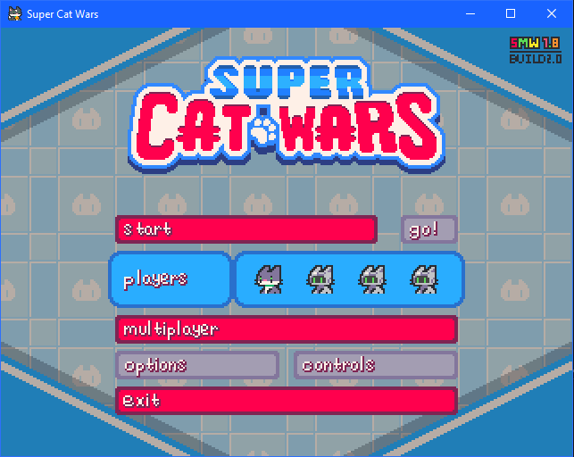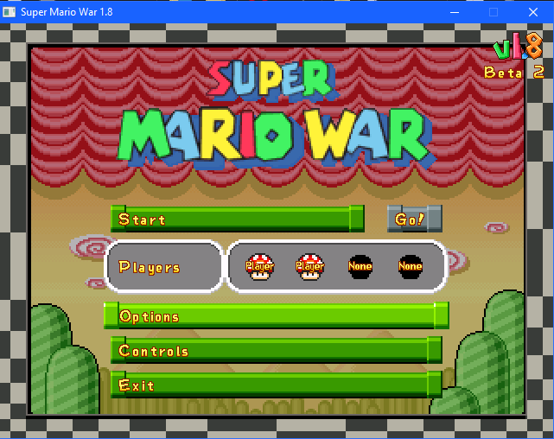
The following options are listed on the main menu:
- START – Select this to proceed to the Match Type menu and start setting up the game.
- GO! – Play an instant randomized match with randomized modes, maps, and settings. Before playing, players can set up their team and skins first (which will be explained in later sections)
- MULTIPLAYER – Join an online multiplayer match via LAN. (SMWar 2.0/Super Cat Wars only) For more information, please see SCW SMWar Online Guide.docx. It is recommended to play online multiplayer via Parsec for less limitations and bugs.
- OPTIONS – Change options for the game. This will be explained in a later section.
- CONTROLS – Change controls for all players, and choose to use a compatible physical controller for playing the game.
- EXIT – Quit the game and exit to desktop.
SECTION 02 – Controls
This section denotes the default controls for each player, based on the mmatyas/SMWar 2.0 version of Super Cat Wars. To map new keys or use a controller, select CONTROLS in the main menu.
PLAYER 1 (default team: RED)
GAME ACTION | DEFAULT KEY | MENU ACTION | DEFAULT KEY
Left | Left | Up | Up
Right | Right | Down | Down
Up | Up | Left | Left
Down | Down | Right | Right
Turbo | LCTRL (Left CTRL) | Select | ENTER
Use Item | LSHIFT (Left Shift) | Cancel/Exit | ESC
Pause | ENTER | Random | Spacebar
Exit | ESC | Fast Map Select | LSHIFT (Left Shift)

PLAYER 2 (default team: GREEN)
GAME ACTION | DEFAULT KEY | MENU ACTION | DEFAULT KEY
Left | A | Up | W
Right | D | Down | S
Up | W | Left | A
Down | S | Right | D
Turbo | E | Select | E
Use Item | Q | Cancel/Exit | Q

PLAYER 3 (default team: YELLOW)
GAME ACTION | DEFAULT KEY | MENU ACTION | DEFAULT KEY
Left | G | Up | Y
Right | J | Down | H
Up | Y | Left | G
Down | H | Right | J
Turbo | U | Select | U
Use Item | T | Cancel/Exit | T

PLAYER 4 (default team: BLUE)
GAME ACTION | DEFAULT KEY | MENU ACTION | DEFAULT KEY
Left | L | Up | P
Right | ‘ | Down | ;
Up | P | Left | L
Down | ; | Right | ‘
Turbo | [ | Select | [
Use Item | O | Cancel/Exit | O

SECTION 03 – Match Types
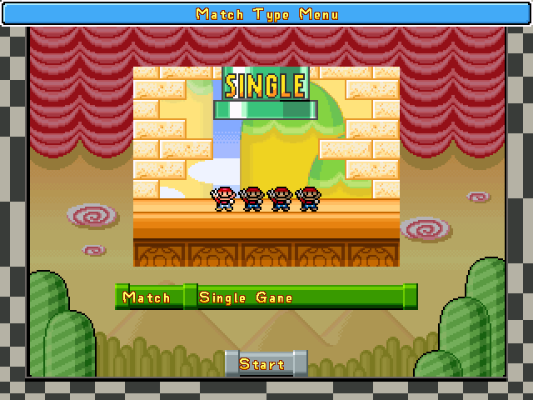
There are five match types in the game. Depending on the type of the match, the players may be assigned to battle across set game modes and maps with special rules.
- SINGLE GAME – Lets you play any map and game mode at your own pace.
- TOURNAMENT – This is similar to Single Game, but features a points system where players get points by winning game modes. The player that reaches the target number of wins will be declared the winner.
- TOUR – Tour Match puts players in pre-determined games & matches known as “Tour Stops”. They have set game modes and even set maps. When a player wins a tour stop, they get points, depending on how well they performed during the match. The player with the greatest number of points wins the entire Tour.
- WORLD – Players are put on a world map, where they can adventure around to score as much points as possible by completing “levels” (pre-determined tour stops) and dealing with patrolling enemies and vehicles along the way. They can also obtain items from Shops / Toad Houses to get an advantage over other players, and obtain special items like clouds and colored keys to help explore the map even more. The player with the most points wins, similar to Tour Mode.
- MINIGAME – Players can pit against three boss types and special minigames that are exclusive to World Mode at any time. In Super Mario War 1.8 Beta 2, it was once considered as a secret Match Type, only accessible by inputting a code on the Match Type screen similar to the Konami Code: UP-UP-DOWN-DOWN-LEFT-RIGHT-LEFT-RIGHT-SPACE-SPACE-SPACE, however in the mmatyas build (SMWar 2.0) and Super Cat Wars, this mode is unlocked from the start.
SUBSECTION 03.1 – SINGLE GAME
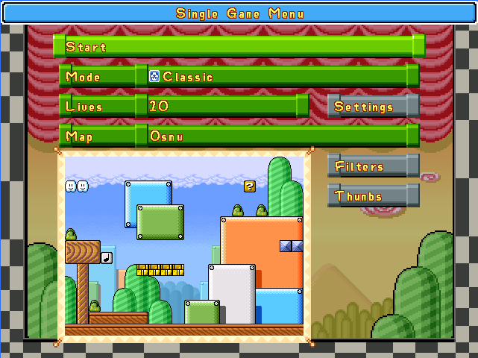
In Single Game’s menu, you can set the following settings for the currently-played match:
- START – Starts the match immediately.
- MODE – Shows the currently-selected game mode. Select it and press LEFT or RIGHT to scroll between game modes.
- LIVES/KILLS/TIME/etc. – This basic parameter can be changed, depending on which game mode. For example, Stomp & Frag Limit shows the number of kills needed to win, and Star & Classic show the number of lives for the players.
- SETTINGS – Shows more advanced parameters for the current selected game mode.
- MAP – Currently selected map. Select it to change the map currently being played. Left-Right changes the map by one map, LSHIFT+Left & Right scrolls by a skip count of 10 maps. Repeatedly pressing a letter lets you cycle through maps that start with the letter in question.
- FILTERS – Selects a group of maps that meet certain criteria, like moving platforms, item blocks, warps, etc. You can also create custom filters by making new text files for them and listing down the maps and the icon of the filter (which is determined by a number). This will be explained in a later section.
- THUMBS – Displays nine maps at a time with a thumbnail-styled view, allowing for easier viewing of the various maps. Press LSHIFT+UP or DOWN or scroll up or down off the screen to navigate pages. All maps are listed in alphabetical order.
SUBSECTION 03.2 – TOURNAMENT
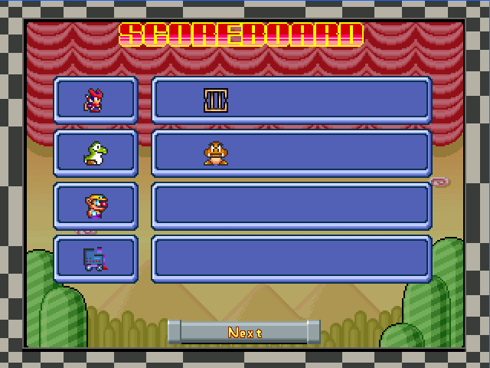
A Tournament is a match type where players must compete to get to the target number of wins, by winning different matches and game modes. The number of wins to be declared a winner can be set when selecting Tournament from the Match Type menu.
Setting up different battles in Tournament mode is just like in Single Game – you can set the match, game mode, and its parameters.
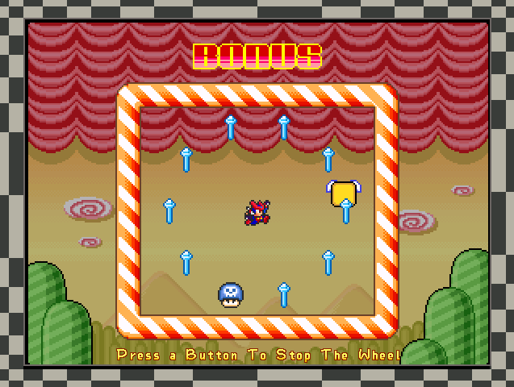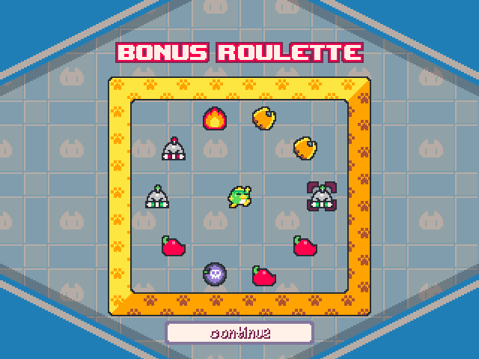
(Zero: WHY ARE YOU ALL GIVING ME MAGIC WANDS???)
At the end of the tournament, the winning player is greeted with a Bonus Wheel that the player can spin to choose a random item to be put in their reserve box for the next match. Players will have the selected item in their reserve box when they start a new match, and can be used by pressing LSHIFT. If the player is unlucky enough to select a Poison Mushroom, the reserve box will be completely locked until they get another Bonus Wheel or they clear stored items in Settings.
Depending on settings, the Bonus Wheel can also be set to appear in every game the player completes, and the item pool may depend on the Item Selection settings.
SUBSECTION 03.3 – TOUR
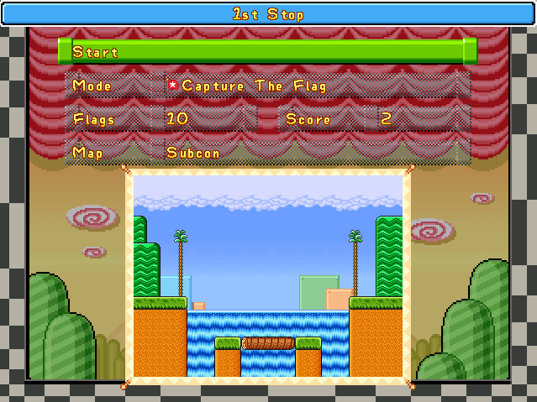Tour Mode pits the players against each other in a number of predetermined games, known as Tour Stops. These are assigned with pre-determined game modes, maps (if any, otherwise a random map is picked), points, and mode parameters.
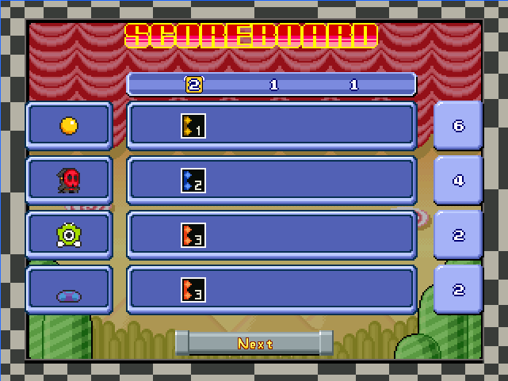
Players receive points depending on how well they performed in each game, for example, winners get the greatest number of points while last-placers get the least number of points. Some tour stops may have a Bonus Wheel assigned to them, with this opportunity being marked by a winged yellow block or target cursor.
Players can also create custom tours by making a text file in the game’s Tours subdirectory, following the correct format (check simple.txt for more information).
SUBSECTION 03.4 – WORLD
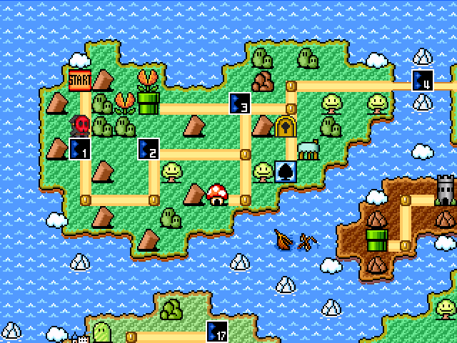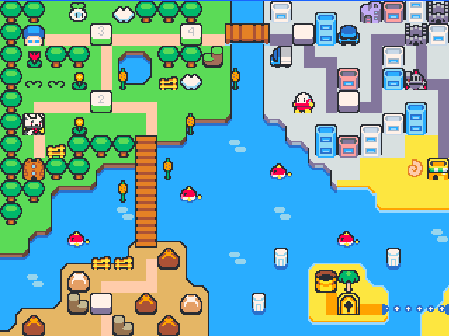
In World mode, players explore a world map and travel to compete in different matches in “levels”, while also dealing with obstacles along the way like enemies, vehicles, drawbridges, and key doors. NOTE: In this mode, there is no way to save your progress, so quitting the match may result in all progress lost.
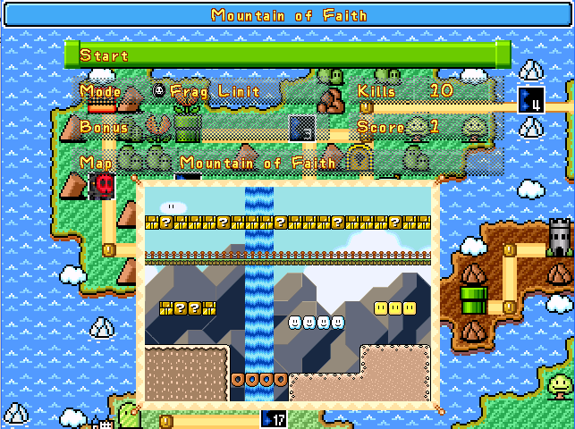
Levels contain pre-determined matches known as Map Stops, in a similar fashion to tour stops. Not only they have an exclusive map and game mode, it also has bonus items granted to the players upon winning the match. As a player wins a match, they get a number of points (which can also be changed with Score Coins). World Mode ends if the players reach and complete the FINAL stage, and the winner is determined by the total number of points attained throughout the match.
On a world map, there are special stages and objects, as follows:
ENEMIES & VEHICLES
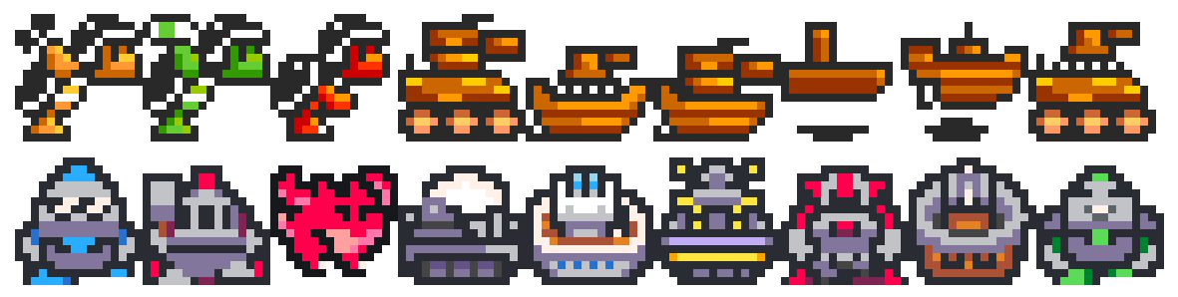These moving stages (known collectively in the world editor as “vehicles”), force the player into a stage immediately once walked over. Once a stage is complete, said vehicles/enemies will move on the map a certain number of times (depending on settings in the world editor). Should the player use a Magic Flute/Music Box, they will stop forcing the player into stages and stop moving, but they can be entered like normal levels.
Super Mario War: Hammer Bro, Boomerang Bro, Fire Bro, Tanks, Airships, Boats
Super Cat Wars: Captain Kallio, Red Dragon, Kobolt, Mizu, Gorudo, Lord Iridium, Tank, Airship, Boat
DRAWBRIDGES
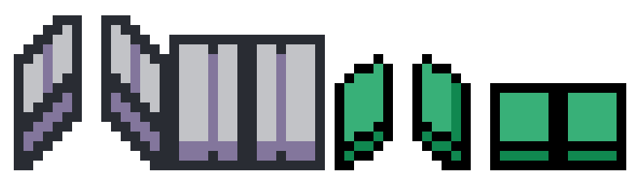
Drawbridges prevent or allow entry of players into other paths depending on if they are open or not. The status of each Drawbridge can be changed if a player completes one match or uses the Watch / Hourglass.
COLORED DOORS
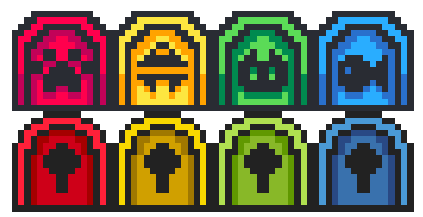
Colored doors block off entry to other paths, unless if the player unlocks it with the correct Colored Key in hand. For example, red keys unlock red doors. SCW features doors with corresponding symbols as general colorblind support, and keys are also affected by this change.
SHOPS / TOAD HOUSES
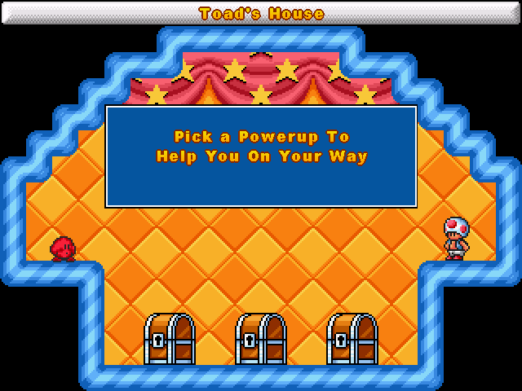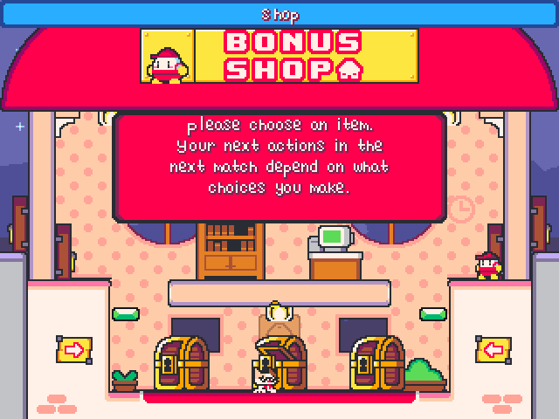
Some levels can be set as Shops / Toad Houses. The player is greeted with the Shopkeeper (SCW) / Toad (SMWar), who has one to five treasure chests containing a set of items. The chests’ contents can be randomized with one another or display a consistent set of items that doesn’t change per play. To open a Treasure Chest, press TURBO. Only one item can be obtained, and the level is considered “completed” once an item has been obtained.
If a player has obtained an item, other players can press SELECT (Enter for P1) to instantly jump back to the world map. The players can also use Replay Blocks/Replay Disks to go back to a Shop/Toad House and choose items again.
SUBSECTION 03.5 – MINIGAME
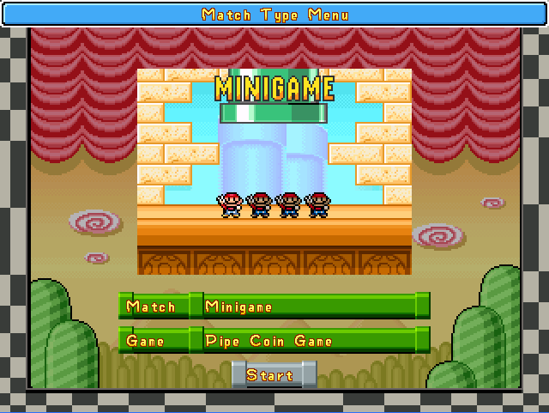Minigame Mode allows players to play the World Mode-exclusive minigames: Boxes Minigame, Pipe Minigame, and Boss Battles.
In Super Mario War 1.8 Beta 2, it was initially designed as a secret match type. To unlock this mode in this version, perform the Konami Code: UP-UP-DOWN-DOWN-LEFT-RIGHT-LEFT-RIGHT-SPACE-SPACE-SPACE. SMWar 2.0 and Super Cat Wars have this mode unlocked from the start.
The following is a summary of the game modes available in Minigame Mode, with Section 05: Game Modes containing more details.
- BOXES MINIGAME – Several crates are scattered across a small map. Players must break the crates to find all the coins. The player can then collect all five coins in order to win, but other players may also hold coins, which hinder the leading player’s progress. Stealing coins can be done by killing players, though.
- PIPE MINIGAME – Referred to on Minigame Mode as “Pipe Coin Game”, Pipe Minigame is a race to 50 coins similar to Coin Collection, but a single warp pipe spawns coins, powerups, and even fireballs.
- HAMMER BOSS – Pits the players against Dark Kallio in SCW or Sledge Brother in SMWar.
- BOMB BOSS – Pits the players against Swashbuckler Baburu in SCW or Bomb Brother in SMWar.
- FIRE BOSS – Pits the players against Stargazer Leonne in SCW or Flame Brother in SMWar.
SECTION 04 – Team & Character Selection
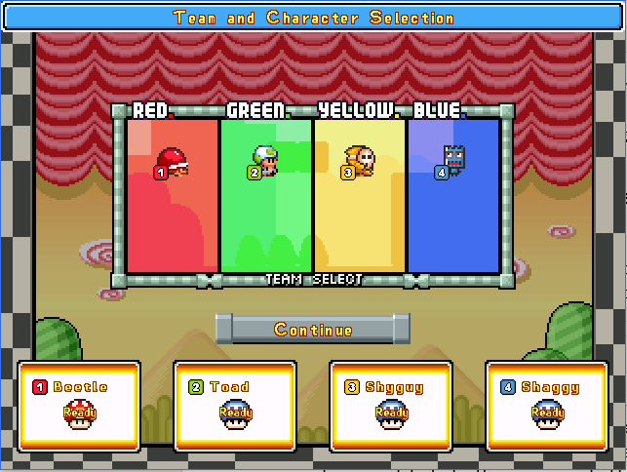
After selecting a Match Type, players will be prompted to choose their team color and character. The following controls are used to change character:
- UP/DOWN – Select skin. Hold Up/Down (SMWar 2.0 & Super Cat Wars only) to scroll faster.
- LEFT/RIGHT – Switch team color.
- UP+DOWN SIMULTANEOUSLY – Picks a random skin from the list.
- LEFT+RIGHT SIMULTANEOUSLY – Sets the current skin to RANDOM. Random is a special type of skin that cycles through different skins every time a match starts. This is represented by the letter R in SMWar, or the ? symbol in SCW.
- ENTER – Confirm skin and team color. Press again when all players have confirmed their skins to proceed to the next screen.
Two or three players can be on the same team, where they share points and lives together. Depending on settings, team players can bounce off their other teammates’ heads instead of stomping them. However, said players do not share a single reserve box, and instead have two or three separate reserve boxes on the same team.
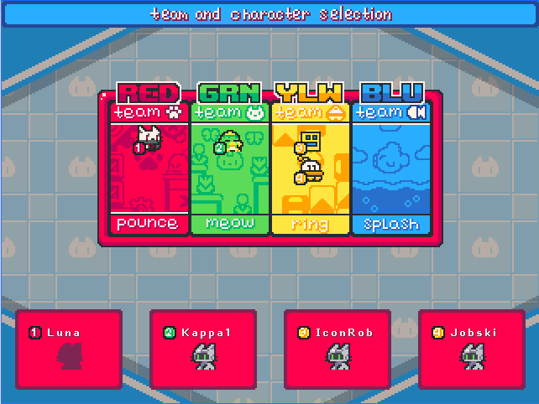
In Super Cat Wars, team colors are now differentiated with actual team names and symbols. Team Red is Team Pounce (Pawprint), Team Green is Team Meow (Cat face), Team Yellow is Team Ring (Bell), Team Blue is Team Splash (Fish). These team differentiations will play a huge role in branding their symbols on various mode objects and assets in the game.
The reason why I put special team names and symbols is for colorblind accessibility – since the original SMWar uses colors to denote teams, it can be difficult for colorblind users to tell what team they are on and what their owned objects are, like domination bases, flags, flag bases, etc. With this concern in mind, I put these colorblind symbols and team names to address this.
SECTION 05 – Game Modes
There are 22 playable game modes in Super Cat Wars / Super Mario War as of 1.8 Beta 2/2.0 (mmatyas build). Each gamemode has a varying objective, whether by collecting points by becoming a chicken, killing enemies, bringing bells/eggs to kittens/Yoshis, and evading transformation into robots/Shy Guys.
Should the player reach the target number of points, kills, or just simply be the last one standing, the player is declared a winner. Other players may be ranked based on how many points they had or what order they were eliminated in. This ranking system plays a significant role in gaining points in Tours, as well as items in World mode.
Modes are classified into the following types:
- Lives – As players lose lives in some modes, the last one standing will be declared the winner.
- Kills – Players gain points by stomping or killing other players/entities.
- Items – This mode is centered around items.
- Point Collection – Specific conditions allow players to gain points at a specific rate, like becoming a chicken or tagging as much bases as possible.
- Point Deduction – This mode is centered around reducing players’ points to the point they are eliminated from the game.
- World Minigame – This mode is exclusive to the World/Minigame match types.
SUBSECTION 05.1 – Classic
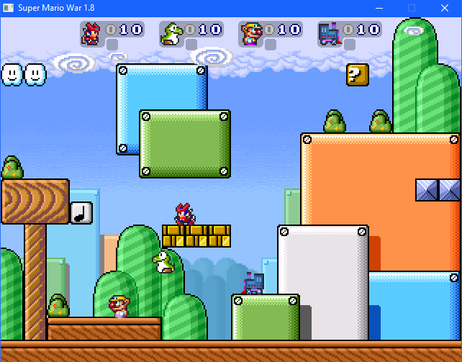TYPE: Lives
DESCRIPTION: The classic free-for-all mode which is a staple in Super Mario War and Super Cat Wars. Players are tasked to stomp on other opponents or even hurt each other with powerups to reduce their opponents’ lives to zero and eliminate them from the game. The last player standing is declared the winner.
SETTINGS:
- LIVES – Basic parameter. Sets the number of lives between 5-100 in intervals of five. When set to Unlimited, the game goes on endlessly.
- ON KILL – Advanced parameter. Determines what happens to the player if they lose a life. Respawn causes players to lose their current weapon and respawn somewhere else, while Shield lets them keep their weapons while giving themselves a protective shield.
SUBSECTION 05.2 – Frag Limit
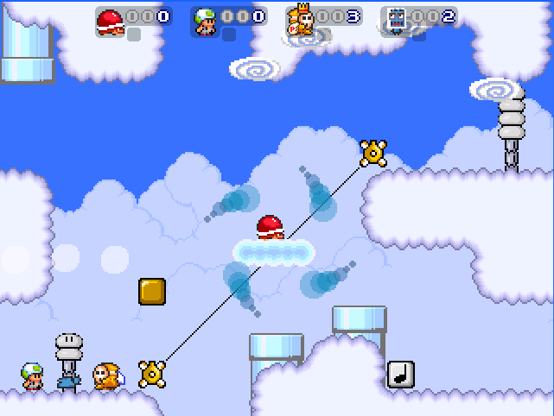TYPE: Kills
DESCRIPTION: In this mode, players must attain points by defeating each other with stomps or items, just like in Classic mode. The player who reaches the target score first will be declared the winner.
SETTINGS:
- KILLS – Basic parameter. Sets the number of required kills between 5-100 in intervals of five. When set to Unlimited, the game goes on endlessly.
- ON KILL – Advanced parameter. Determines what happens to the player if they lose a life. Respawn causes players to lose their current weapon and respawn somewhere else, while Shield lets them keep their weapons while giving themselves a protective shield.
- SCORING – Advanced parameter. Determines the method by which players score. All Kills lets player score points by any means of killing, while Push Kills Only allows players to score points by pushing other players into hazards only.
SUBSECTION 05.3 – Time Limit
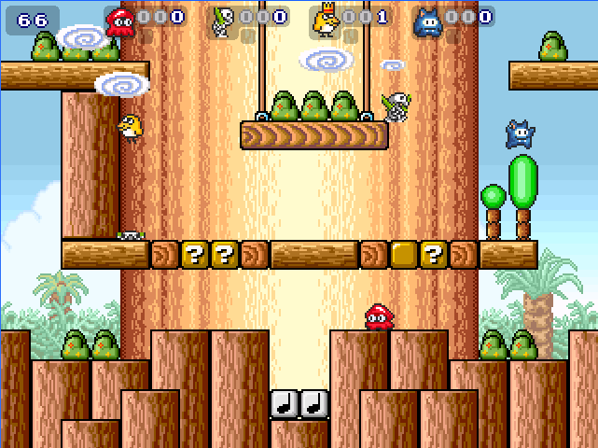TYPE: Kills
DESCRIPTION: This is a timed version of Frag Limit. The players must attain the highest number of kills in a set amount of time.
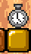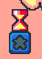
There are also clocks/hourglasses that give out extra time. Pick these up to extend the game timer and continue playing. Once the time is up, the player with the highest number of kills is declared the winner.
SETTINGS:
- TIME (in seconds) – Basic parameter. Sets the amount of time (in seconds) from 30-600 in intervals of 30. If set to unlimited, the game will go on endlessly.
- ON KILL – Advanced parameter. Determines what happens to the player if they lose a life. Respawn causes players to lose their current weapon and respawn somewhere else, while Shield lets them keep their weapons while giving themselves a protective shield.
- SCORING – Advanced parameter. Determines the method by which players score. All Kills lets player score points by any means of killing, while Push Kills Only allows players to score points by pushing other players into hazards only.
- EXTRA TIME – Advanced parameter. This is a meter that modifies the chance of an Extra Time hourglass/clock to appear in Star/? Blocks & View Blocks. These add extra seconds to the timer when used.
SUBSECTION 05.4 – Jail
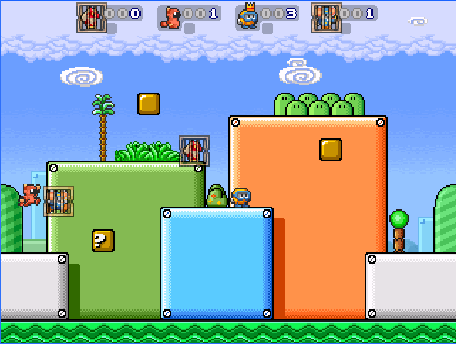TYPE: Kills
DESCRIPTION: This is a variation on Frag Limit where any player who is defeated by a player will be trapped in a jail cage. The jail cage limits their speed and jump height, but a trapped player can be freed from the cage by stomping other players. Like in Frag Limit, the player who reaches the target kill count wins.
SETTINGS:
- KILLS – Basic parameter. Sets the number of required kills between 5-100 in intervals of five. When set to Unlimited, the game goes on endlessly.
- STYLE – Advanced parameter. Determines how the Jail mode is played.
  - Classic Jail – If everyone else gets jailed except for the last remaining player, the latter scores a bonus point.
  - Owned Jail – All jail cages are colored based on the team color of the player that killed them, signifying that the cages are owned by said player. Should all players get “owned” by the player, they will all be freed and the latter gets a bonus point.
  - Free For All Jail – None of the players will get freed immediately from the cages even if everyone is jailed, and no bonus points are given.
- FREE TIMER – Advanced parameter. Determines the number of seconds before a player is automatically freed from a jail cage. If set to None, only kills and Jail keys can free the player.
- TAG FREE – Advanced parameter. Determines if tagging teammates by bumping into one another will free each other from jail.
- JAIL KEY – Advanced parameter. This is a meter that modifies the chance of a Jail Key to appear in Star/? Blocks & View Blocks. These items allow the player to be freed from a jail cage immediately.
SUBSECTION 05.5 – Coin Collection
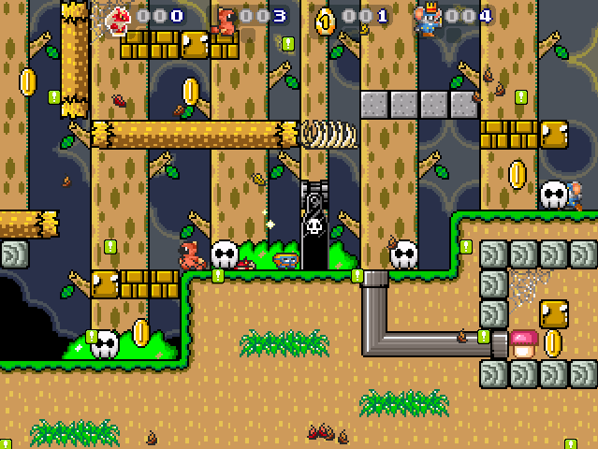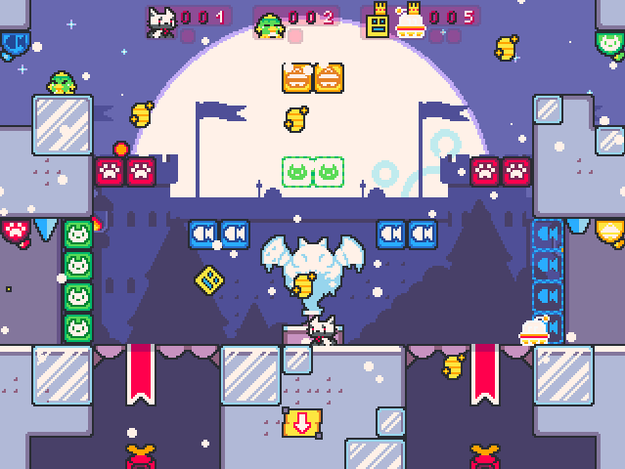
TYPE: Items
DESCRIPTION: Coins appear around the stage. These coins can be collected by the player to score points. The player who reaches the target number of coins first wins.
SETTINGS:
- COINS – Basic parameter. Sets the number of required coins between 5-100 in intervals of five. When set to Unlimited, the game goes on endlessly.
- PENALTY – Advanced parameter. Determines if the player loses a coin or not after they die.
- QUANTITY – Advanced parameter. Determines how many coins can appear on the map, from 1-5.
- EXTRA COINS – Advanced parameter. This is a meter that modifies the chance of a Coin to appear in Star/? Blocks & View Blocks.
SUBSECTION 05.6 – STOMP
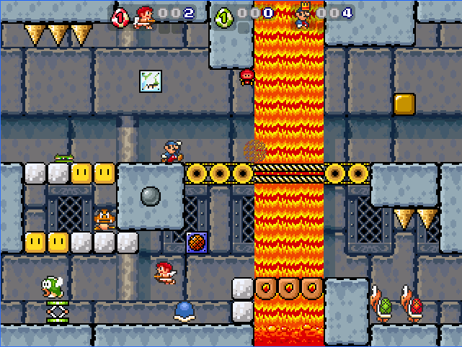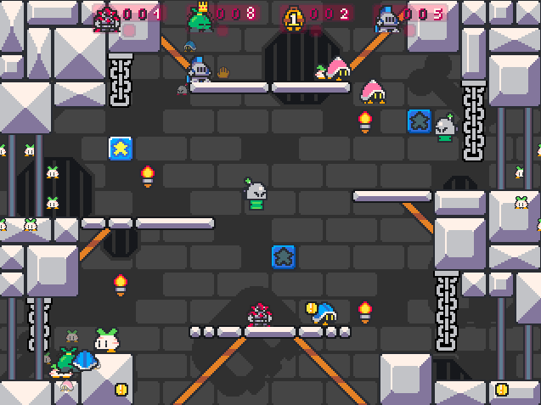
TYPE: Kills
DESCRIPTION: Many enemies appear on the stage. The following include:
- 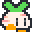 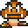Turnip/Goomba – Basic enemy that can be stomped on.
- 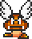Flying Turnip/Paragoomba – Upgraded version of the previous enemy that bounces across the screen. It must be stomped twice to be defeated.
- 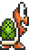Tin Soldier/Koopa Troopa – Stomping on these enemies turn them into green shells that can be tossed across the map.
- 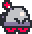 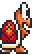Tin Wheeler/Red Koopa Troopa – Acts similarly to above, but these variants turn around when they hit the edge of a tile or semisolid tile. Stomping on these enemies turn them into red shells.
- 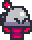 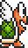 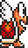Bouncing Tin Soldier/Koopa Paratroopa – Upgraded version of the previous enemy that bounces across the screen. When defeated, it is turned into a shell. There are green & red variants.
-  Beetle/Buzzy Beetle – An enemy that cannot be defeated by projectiles like fireballs. When defeated, it is turned into a Beetle shell.
- 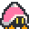 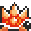Wood Beetle/Spiny – An enemy that is dangerous to jump on. It can still be defeated with various methods, however, and can be transformed into a Wood Beetle/Spiny shell by ground-pounding.
- 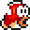Fish/Cheep Cheep – An enemy that jumps in a varied arc across the screen. As it flies very fast, the recommended way to defeat it is to use projectiles or proper timing of a stomp. These also come in three alternate forms, but are all aesthetic.
As this mode is focused on enemies, players must attain as many kills as they can by defeating enemies. Kills are not attained by killing enemy hazards like Cannonballs/Bullet Bills, Mr. Prickles & Bamboo Blossom/Piranha Plants, and Monkeys & Vulcan Turnips/Fire Piranha Plants. The player who reaches the target kill count first is declared the winner.
SETTINGS:
- KILLS – Basic parameter. Sets the number of required kills (enemy only) between 10-200 in intervals of ten. When set to Unlimited, the game goes on endlessly.
- ENEMY SLIDERS – Advanced parameter. Each enemy type has a slider that determines relative probabilities of each enemy appearing during this match. Lowest results in the enemy not appearing at all. Higher positions of the cursor allow for higher chances of that enemy appearing.
- RATE – Advanced parameter. Determines how often new enemies appear via Very Slow, Slow, Moderate, Fast, Very Fast. In SMWar 2.0 and Super Cat Wars, two new spawn rates are added: Extremely Fast and Insanely Fast, which is probably… not recommended if you don’t want your map flooded to insanity with enemies.
SUBSECTION 05.7 – Bells & Kittens (Yoshi’s Eggs)
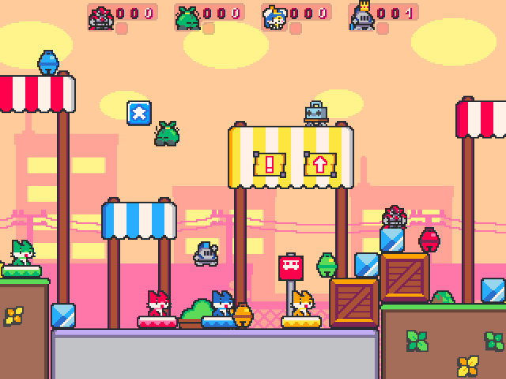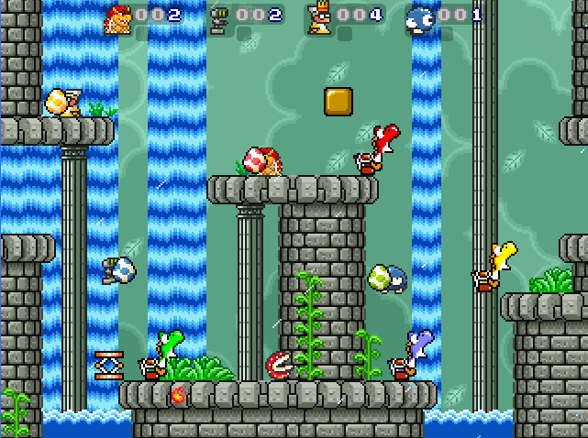
TYPE: Items
DESCRIPTION: There are colored kittens/Yoshis scattered around the stage, as well as colored eggs. Players must carry the bells/eggs to the correct kittens/Yoshis to score points. Should the player get the target number of delivered eggs, that player is declared the winner.
In Super Cat Wars, there is a Colorblind setting that makes the kittens and bells colorblind-friendly, with the shapes of bells based on shapes of the team emblems (like in Magic Bells/Star mode), and the kittens’ platforms marked with team emblems.
SETTINGS:
- BELLS/EGGS – Basic parameter. Sets the number of required delivered bells/eggs between 5-100 in intervals of five. When set to Unlimited, the game goes on endlessly.
- KITTEN (YOSHI) & BELL (EGG) SLIDERS – Advanced parameter. Determines how many kittens/Yoshis and bells/eggs of a specific color appear on the screen.
- EXPLOSION TIMER – Advanced parameter. Sets if the bells/eggs are set to have a timed explosion, which hurts all players. As they are about to explode, a countdown timer is displayed on them and they shake faster.
SUBSECTION 05.8 – Capture the Flag
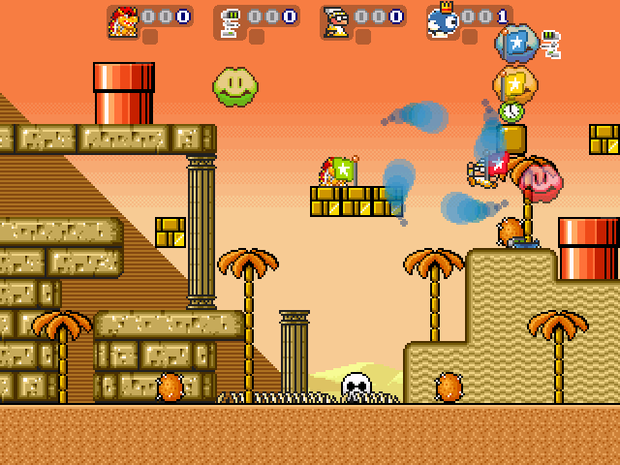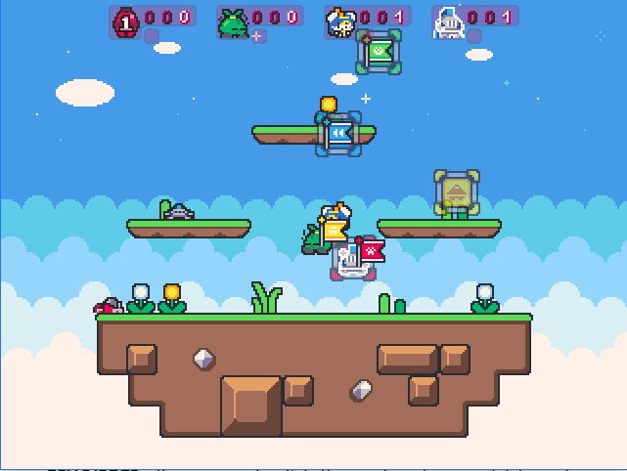
TYPE: Items
DESCRIPTION: Teams are assigned flag bases with flags on them. Other team players can steal flags from the opposing team and bring them to their own base to score points. The team that reaches the target points is declared the winner.
In Super Cat Wars, the flags and bases are now colorblind friendly, featuring team emblems that correspond to the team color itself.
SETTINGS:
- FLAGS – Basic parameter. Sets the number of captured flags between 5-100 in intervals of five.
- SPEED – Advanced parameter. This is a slider that sets the speed of the flag bases. If set to 0 (second-to-left node in SMWar 2.0), the flag bases will be stationary and will stop moving, however they will change positions every few seconds.
  - Exclusive to SMWar 2.0/Super Cat Wars is the ability to set the flag bases to be stationary without any change in positions over time. This setting is “-1” if you are setting up Tour Mode in legacy versions, but SMWar 2.0 allows for setting this special parameter in-game & in the World Editor.
- TOUCH RETURN – Advanced parameter. Determines if the player can return their own flag to their own base by touching the latter while holding the flag.
- POINT MOVE – Advanced parameter. Determines if the flag base will change positions on the map after its team has scored.
- AUTO RETURN – Advanced parameter. Determines how long should an untouched flag stay untouched before being returned to base automatically.
- NEED HOME – Advanced parameter. Determines if the player needs their flag on their base to score points.
- CENTER FLAG – Advanced parameter. A flashy colorful flag appears on the map, and can be grabbed by anyone. The team must return that flag to their own base to score a point.
SUBSECTION 05.9 – Chicken
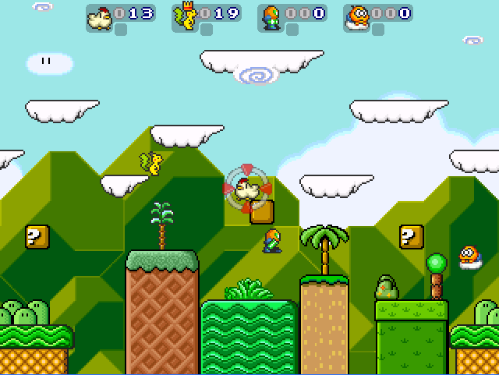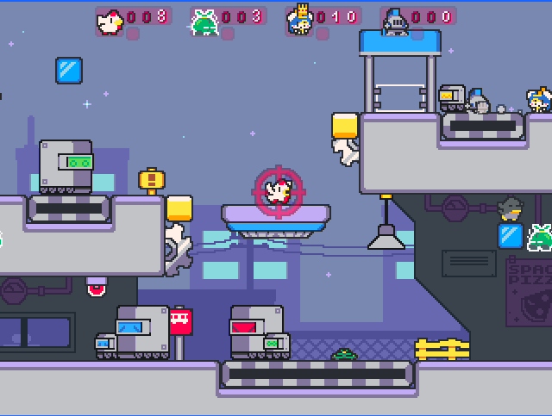
TYPE: Point Collection
DESCRIPTION: To slowly gain points, the player must become the chicken. The first player to defeat another player becomes the chicken, (with a text cue saying “Chicken!”) and scores points. The chicken can stomp other players to score extra points (which is also accompanied by a loud chicken cry sound to signify this).
Notably, the chicken loses its ability to run, but it also gains a permanent gliding ability, depending on settings. Other players can steal the chicken status by defeating the chicken. The chicken status can also be lost by accidentally colliding with a stage hazard or enemy. The player who reaches the target score wins.
SETTINGS:
- POINTS – Basic parameter. Sets the number of points between 50-1000 in intervals of fifty. When set to Unlimited, the game goes on endlessly.
- SHOW TARGET – Advanced parameter. Toggles a crosshair target icon that makes it easier for other players to spot the chicken.
- CHICKEN GLIDE – Advanced parameter. Determines if the chicken can glide, like the glide ability that comes with Tanuki’s Tail/Super Leaf.
SUBSECTION 05.10 – Tag
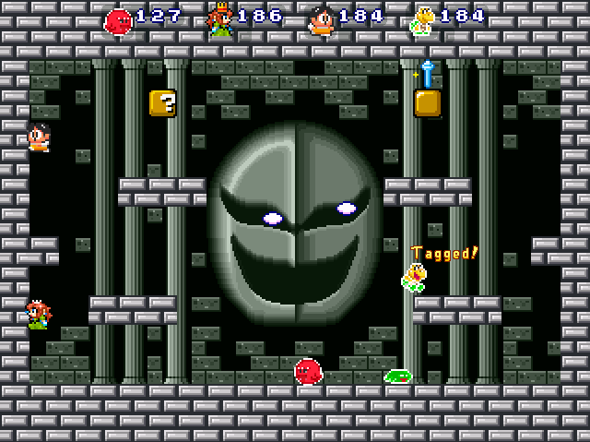
Don’t let that menacing face distract you from the fact Koopa is draining his points.
TYPE: Point Deduction
DESCRIPTION: The match begins with a player randomly selected as the It, which is marked by inverted or distorted color schemes. The It loses points over time, until it reaches zero, which eliminates the player from the game. To transfer the It status to another player and survive, they must tag them by touching said player or hitting them with projectiles. It’s still possible to lose 5 points while you’re not the It by dying, though.
If a player dies while being the It, another player will be marked as such. The last player standing will be declared the winner.
SETTINGS:
- POINTS – Basic parameter. Sets the number of points between 50-1000 in intervals of fifty. When set to Unlimited, the game goes on endlessly.
- TOUCH TAG – Advanced parameter. Determines if the player must kill or touch another player to make them It.
SUBSECTION 05.11 – Magic Bells (Star)
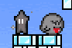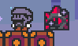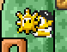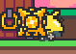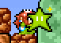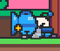
TYPE: Items
DESCRIPTION: This mode is also unique in the sense that its settings actually feature three variations of this game mode. Depending on certain conditions, players must either avoid holding the bell or just hold on to the bell to survive, otherwise, if the timer goes down, the player(s) may lose a life. The last player standing is declared the winner.
In Super Cat Wars, bells in the Multi-Bell/Multi-Star mode are now colorblind-friendly, with their shapes resembling those of the teams’ emblems.
SETTINGS:
- LIVES – Basic parameter. Sets the number of lives between 1-20 in intervals of one. When set to Unlimited, the game goes on endlessly.
- TIME – Advanced parameter. Determines how much time before the players are eliminated under specific conditions.
- BELL/STAR TYPE – Advanced parameter. Determines which type of bell is used (see images above):
  - DARK BELL/ZTAR – Players will be shrouded in darkness (Corrupted/Ztarred) and will be prone to being killed when the time is up. Corrupted/ztarred players must pass the bell onto another player to transfer that status and avoid themselves from getting killed.
  - GOLDEN BELL/SHINE SPRITE – Players must fight for the Golden Bell/Shine Sprite, which will grant complete nullification from the timer’s effects once held by the player. This status is known as “Shiny” status. All other players who do not have the Shiny Status will be killed by the timer.
  - MULTI-BELL/MULTI-STAR – Three players are given different colored bells/stars, with the one player without a bell/star to be eliminated by the timer. To survive, the player without a bell/star must steal one of the bells/stars from another player, which will change color depending on which team is carrying it.
- EXTRA TIME – Advanced parameter. This is a meter that modifies the chance of an Extra Time hourglass/clock to appear in Star/? Blocks & View Blocks. These add extra seconds to the timer when used.
SUBSECTION 05.12 – Domination
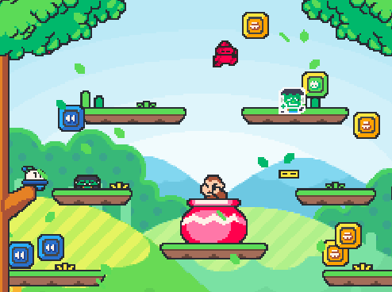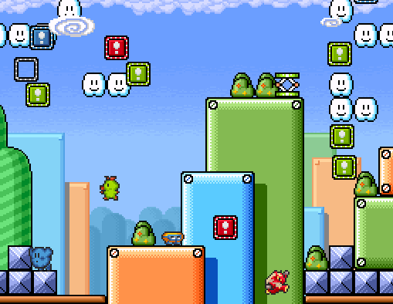
TYPE: Point Collection
DESCRIPTION: There are several base panels scattered across the map. When tagged by a player, the bases will change color to reflect the player’s team, and each base will score points for the player. Should more bases be tagged, the rate of which points are gained increases even further, allowing the player to get more points faster.
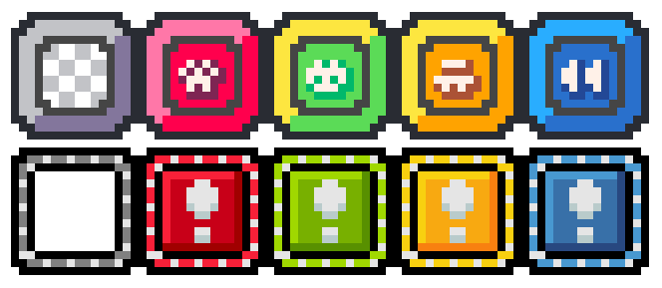
Domination bases in SCW (top)/SMWar (below). Red is P1, Green is P2, Yellow is P3, Blue is P4.
It's possible to lose bases, make them shift positions, or have them stolen (depending on settings) if you are defeated by another player. Should this happen, the rate at which points are accrued by you will be slowed down. The player that reaches the target point count first will be declared the winner.
In Super Cat Wars, domination bases are now colorblind friendly, with a team symbol representing each of the team colors.
SETTINGS:
- POINTS – Basic parameter. Sets the number of points between 50-1000 in intervals of fifty. When set to Unlimited, the game goes on endlessly.
- QUANTITY – Advanced parameter. Determines how many bases can appear on the map. It can be set from the following:
  - 1-10 bases
  - # of players – The number of bases depends on the number of players.
  - # of players (-/+) # – Same as above, but the number of bases can be added or subtracted by a certain value.
  - 2x players – The number of bases depends on twice the number of players.
  - 2x players (-/+) # – Same as above, but the number of bases can be added or subtracted by a certain value.
- ON DEATH – Advanced parameter. There are three options that can be toggled to show what will happen to the bases if the player dies.
  - LOSE BASES – The player in question will lose their bases if they die, reverting back to their normal grayed out state and stopping points from being gained.
  - MOVE BASES – Bases will shift positions every time a player dies.
  - STEAL BASES – The player in question will have their bases stolen by another player that killed them.
SUBSECTION 05.13 – King of the Hill
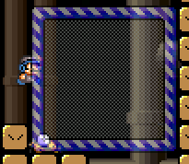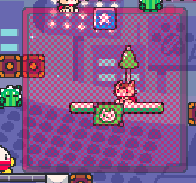
TYPE: Point Collection
DESCRIPTION: In King of the Hill, there is a square-shaped zone of a specific size. If a player stands inside that zone, they will gain points while the zone flashes their team color. Depending on settings, the zone may start to relocate to another location. If other opponents stand inside the zone with the player, the zone will stop giving the players points and turn gray again, until the players step out of the zone until one player is left inside the zone, which will make said player earn points again.
The player who reaches the target point count first will be declared the winner.
SETTINGS:
- POINTS – Basic parameter. Sets the number of points between 50-1000 in intervals of fifty. When set to Unlimited, the game goes on endlessly.
- SIZE – Advanced parameter. Determines the size of the square zone, from 2x2 tiles to 5x5 tiles. In SMWar 2.0 & Super Cat Wars, the square zone can now be set to the larger 6x6 and 7x7 sizes.
- RELOCATE – Advanced parameter. This is the amount of time (measured in seconds or minutes) to wait until the square zone moves again. It can be set from 5 seconds to 45 seconds in intervals of five, and from 1 minute to 3 minutes in intervals of 0.5. If set to NEVER, the square zone will never relocate at all.
- MAX MULTIPLIER – Advanced parameter. Every few seconds, a multiplier will cover the square zone to multiply gained points by x2, x3, x4, and x5. The maximum multiplier can be set here, and setting it to NONE will cause the multiplier to not activate at all.
SUBSECTION 05.14 – Race
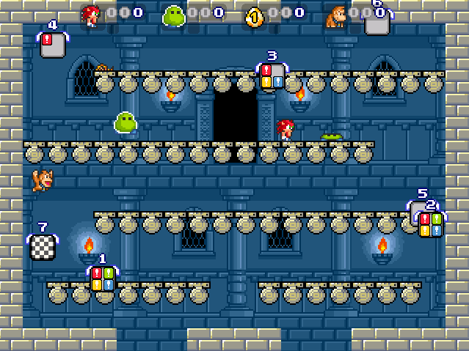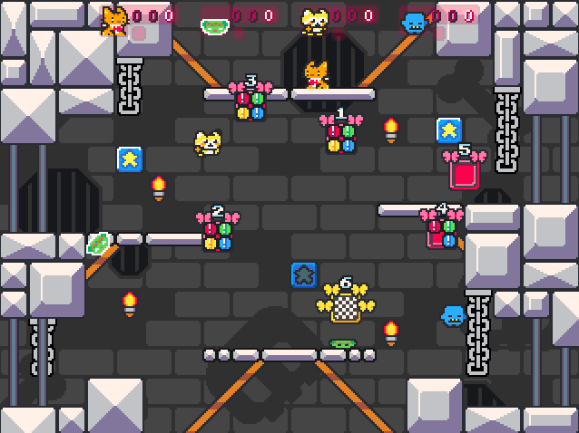
TYPE: Point Collection
DESCRIPTION: In Race mode, the players race around the map to hit different numbered goal panels and then hit the checkered panel at the end to complete a lap. These panels are carried by butterflies in SCW/wings in SMWar, and they can either be stationary or continuously moving (depending on settings).
Once the player has completed the target number of laps, they will be declared the winner of the race.
SETTINGS:
- LAPS – Basic parameter. Sets the number of points between 2-40 in intervals of two. When set to Unlimited, the game goes on endlessly.
- QUANTITY – Advanced parameter. Determines the number of goals needed to complete a lap, from 2 to 8 in intervals of 1.
- SPEED – Advanced parameter. This is the speed at which the race goals move. It can be set to Stationary (which prevents the goals from moving around), Very Slow, Slow, Moderate, Fast, and Very Fast. In SMWar 2.0 and Super Cat Wars, two additional speed options are added: Extremely Fast and Insanely Fast, which… I’m pretty sure that’s just for fun.
- PENALTY – Advanced parameter. If a player dies, their progress on the lap may be affected. Set this to One Goal to make a player step back one goal when they are defeated, or All Goals if you wish to make this even more cruel by losing all goals. Set this to NONE to disable penalty.
SUBSECTION 05.15 – Owned
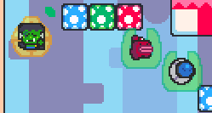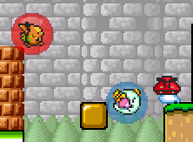
TYPE: Point Collection
DESCRIPTION: In Owned mode, a player can defeat their opponents to “own” them. To denote this, a colored bubble (or team symbol and color in SCW for colorblind accessibility) is placed over the opponent that the player has stomped on.
At least one player is needed to generate points, with two or three owned players giving twice or thrice the points. Defeating a player already-owned by you will give you bonus points, while defeating players owned by other opponents will let you own them as well.
The player that reaches the target point count first will be declared as the winner.
SETTINGS:
- POINTS – Basic parameter. Sets the number of points between 50-1000 in intervals of fifty. When set to Unlimited, the game goes on endlessly.
SUBSECTION 05.16 – Frenzy
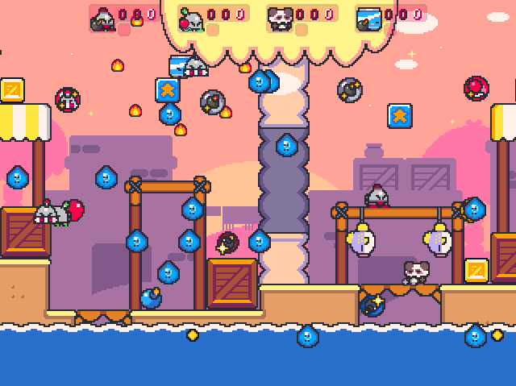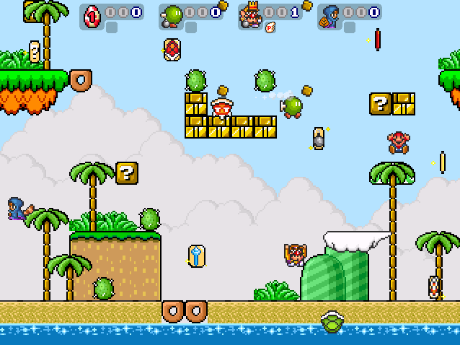
TYPE: Kills/Items
DESCRIPTION: Frenzy Mode is similar to Frag Limit, but Item Bubbles (Item Cards in SMWar) appear on the map, allowing players to obtain weapons and other special items to take out players in an insane battle royale of projectile frenzy.
As per usual, the first player to reach the target number of kills will be declared as the winner.
SETTINGS:
- KILLS – Basic parameter. Sets the number of kills between 5-100 in intervals of five. When set to Unlimited, the game goes on endlessly.
- LIMIT – Advanced parameter. Determines how many Item Bubbles/Cards can appear on the screen, with the following options available:
  - Single powerup
  - 1-5 powerups
  - # of players – The number of powerups depends on the number of players.
  - # of players (+) # – Same as above, but the number of powerups can be added by a certain value.
- RATE – Advanced parameter. Sets the rate at which Item Bubbles/Cards spawn, from 1, 2, 3, 5, 10, 15, 20, 25, or 30 seconds. Instant sets bubbles/cards to spawn immediately once one of them is obtained.
- STORE SHELLS – Advanced parameter. Sets if shells are stored in the player’s reserve box (can be used by pressing Use Item), or are immediately held by the player and may be kicked immediately unless Turbo is pressed.
- ITEM SLIDERS – Advanced parameter. These sliders set the relative frequency of certain item bubbles/cards appearing. The items listed are ones classified under THROWABLE, COLLECTABLE, RESERVE, and WEAPON, as well as a random bubble/card marked with a ? mark that gives out a random item upon collection.
SUBSECTION 05.17 – Survival
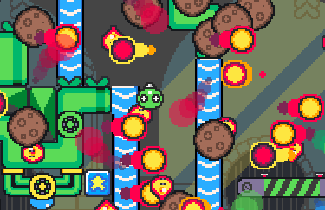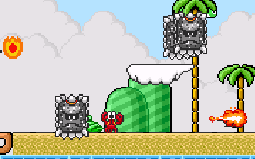
AAAAAAAAGH GOD SAVE US ALL!!!!!! | Ahh, what a nice day at the beach…
TYPE: Lives
DESCRIPTION: Survival Mode is similar to Classic Mode, except players have to survive an ordeal of incoming falling meteors (Thwomps in SMWar), Jumping Fireballs (Lava Bubbles in SMWar), and flying flames. These hazards can be easily avoided in the first half of the game, but as more players die, the density of these hazards increase, so be careful!
The last player standing will be declared the winner.
SETTINGS:
- LIVES – Basic parameter. Sets the number of lives between 5-100 in intervals of five. When set to Unlimited, the game goes on endlessly.
- HAZARD SLIDERS – Advanced parameter. These sliders set the relative frequency of certain hazards appearing on-screen. Set the sliders to the lowest value to completely disable a hazard or two, or set them to the highest value to make them have the highest chance of appearing.
- DENSITY – Advanced parameter. Sets how much of a certain hazard is appearing on the screen, from Very Slow, Slow, Moderate, High, or Very High. In SMWar 2.0 and Super Cat Wars, two extra density options are added: Extremely High and Insanely High, which sure does remind me of a certain bullet hell game from the lands of Gensokyo!
- SPEED – Advanced parameter. Sets how fast the hazards move, from Very Slow, Slow, Moderate, Fast, and Very Fast. In SMWar 2.0 and Super Cat Wars, two extra speed options are added: Extremely Fast and Insanely Fast. Good luck dodging!
- SHIELD – Advanced parameter. Sets if the player gets a shield or not upon respawning.
SUBSECTION 05.18 – Greed
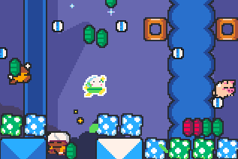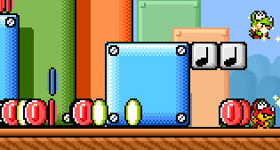
TYPE: Point Deduction/Items
DESCRIPTION: In this mode, players start with a set number of coins. When the players attack each other, they do not die (unless if the player falls into a DEADLY or MILD DEADLY tile type), but rather a lot of their coins spill out from them.
These colored coins correspond to the player’s team color, and can be picked up by other players for extra coins. If left alone, these coins will disappear on their own, with the amount of time adjustable in the settings. The main goal of this game is to reduce the opponents’ coin count to zero by attacking them and dropping/stealing their coins, from which at this point, they are eliminated from the game.
The last player standing will be declared the winner.
SETTINGS:
- COINS – Basic parameter. Sets the number of stored coins between 10-200 in intervals of ten. When set to Unlimited, the game goes on endlessly.
- COIN LIFE – Advanced parameter. Determines how long dropped coins remain on the map before disappearing. It can be set from 1-10 seconds in intervals of one, then 12, 15, 18, 20, 25, and 30 seconds.
- OWN COINS – Advanced parameter. Determines if players can collect their own coins that they dropped.
- MULTIPLIER – Advanced parameter. Sets the multiplier that determines how many coins are dropped from the player when attacked, between 0.5-3 in intervals of 0.5.
- EXTRA COINS – Advanced parameter. This is a meter that modifies the chance of a Coin to appear in Star/? Blocks & View Blocks. Unlike in Coin Collection, there are several types of Coin that can appear:
  - Yellow Coins give 5 extra coins.
  - Red Coins give 10 extra coins.
  - Green Coins give 15 extra coins.
  - Blue Coins give 20 extra coins.

SUBSECTION 05.19 – Health
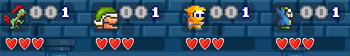
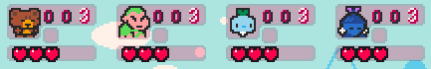
TYPE: Lives
DESCRIPTION: Health is a mode that plays similarly to Classic, but players start with an amount of health points. When players attack each other or fall into hazards, they lose health. Losing all health points results in losing a life, and as per usual, losing all lives will lead to the player being eliminated from the game.
Players can lose half a heart (1HP penalty) via:
- Getting stomped
- Getting hit by projectiles from other players
- Getting hit on a special block by a player hitting it from below
- Getting crushed inside a solidified Dotted-Line Block
- Getting crushed by a Falling Log/Donut Block
- Getting hit by enemy hazards on the map (eg. Cannonball/Bullet Bill, Mr. Prickles & Bamboo Blossom/Piranha Plant)
Players can lose a whole heart (2HP penalty) via:
- Falling into a tile type classified as DANGER, DEADLY or MILD DEADLY. (The latter causes the player to die and respawn, but loses health instead of losing a life)
- Getting crushed between moving platforms
- Getting frozen by an ice spell from the Freeze Pop/Ice Wand, then getting destroyed by another player who touches you
- Falling burnout (Falling for too long)
- Suicide Penalty (Waiting for too long without moving) (can be changed in Gameplay Options)
- Bounds Penalty (Staying on top of the map for too long) (can be changed in Gameplay Options). This will drain the player’s health every second before instakilling the player!
The last player standing will be declared the winner.
SETTINGS:
Note: All advanced parameters are named as such in-game, and are not to be confused with the extra lives that the player has on the score counter.
- LIVES – Basic parameter. Sets the number of lives between 1-20 in intervals of one. When set to Unlimited, the game goes on endlessly.
- START LIFE – Advanced parameter. Sets the players’ starting life from 2-10 in intervals of 1. Note: Start Life cannot be more than the Max Life.
- MAX LIFE – Advanced parameter. Sets the players’ max life from 2-10 in intervals of 1. This max life is affected by collecting Heart Containers that appear in blocks, and these extra health points are permanent.
- EXTRA LIFE – Advanced parameter. This is a meter that modifies the chance of a Heart Container to appear in Star/? Blocks & View Blocks. Heart Containers add an extra 1HP (half a heart) to the player’s HP, and the extra health can go as high as the Max Life.
SUBSECTION 05.20 – Card Collection
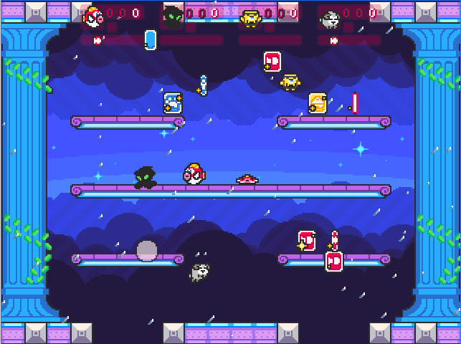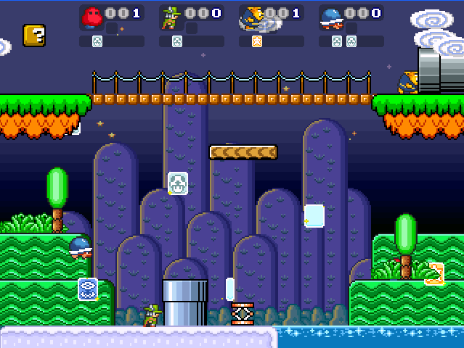
TYPE: Point Collection
DESCRIPTION: Card Collection is a mode where blank cards appear on the map. Touching a card will turn the card into one of these three types of cards:
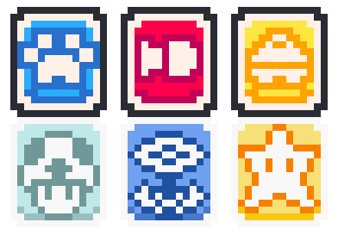
- Pawprint/Mushroom – Holding three of these cards and banking them will grant 2 points.
- Fish/Fire Flower – Holding three of these and banking them will grant 3 points.
- Bell/Super Star – Holding three of these and banking them will grant 5 points.
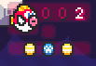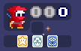
Collecting an assortment of cards which do not make a match will grant the player only 1 point, so making matches is important to gain a lot of points. Note that the player has to wait for the cards to bank once they collected three of them, so they must avoid other players, hazards, or other cards (which can override the last third card collected).
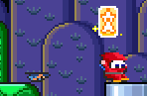
If a player dies, they can drop one of their cards. These cards display the symbol that was shown when the player collected them, but they can disappear on their own or fall into hazards/get crushed, so players must be quick at obtaining these cards so they won’t get lost.
The first player to reach the target point count is declared the winner.
SETTINGS:
- POINTS – Basic parameter. Sets the number of points between 10-200 in intervals of ten. When set to Unlimited, the game goes on endlessly.
- LIMIT – Advanced parameter. Sets how many cards can appear on the map at one time.
  - 1-5 cards
  - # of players – The number of cards depends on the number of players.
  - # of players (-/+) # – Same as above, but the number of cards can be added or subtracted by a certain value.
- RATE – Advanced parameter. Sets how many seconds after a card has been collected by a player before another card appears on the map, between 1-3 seconds in intervals of one, then 5-30 in intervals of five. Set this to Instant to make a card appear on the map right after a card disappears after collection.
- BANK TIME – Advanced parameter. Sets how many seconds should the player wait before their points are banked from the three collected cards, from 1-10 seconds in intervals of one. Set this to Instant to instantly bank their points.
- CARD LIFE – Advanced parameter. Sets how long should any dropped cards stay on the screen before disappearing, from 1-10 seconds in intervals of one, then 12, 15, 18, 20, 25, 30 seconds.
SUBSECTION 05.21 – Ghost Chase/Phanto
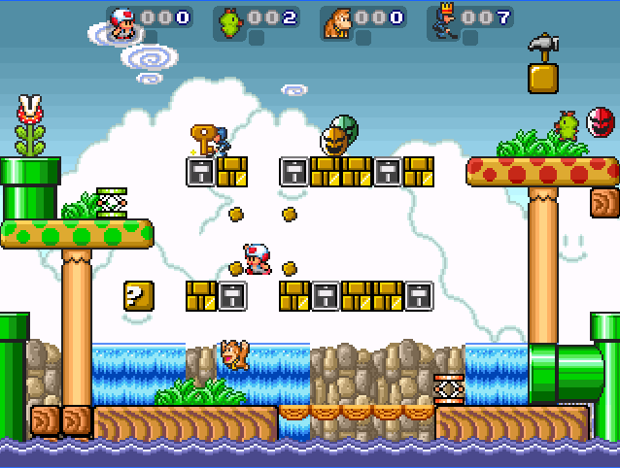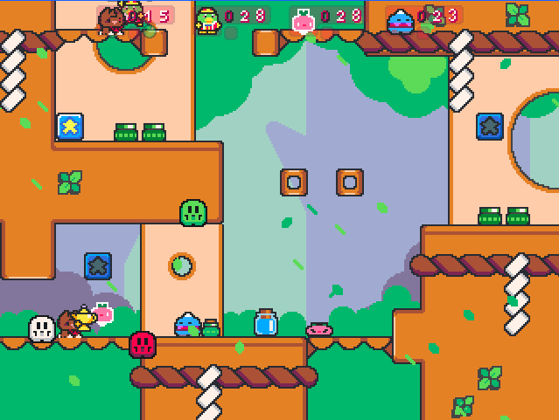
TYPE: Point Collection/Items
DESCRIPTION: Ghost Chase/Phanto is a game mode where players must collect points by holding a Golden Lamp/Key. It looks really easy, until a Ghost/Phanto starts chasing whoever holds the item. Dropping the lamp/key will make the Ghosts/Phantos go away.
There are three types of Ghost/Phanto to avoid in this mode: 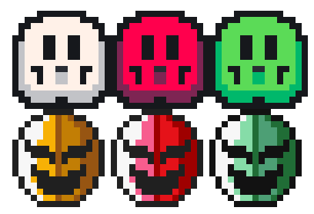
- White Ghost/Yellow Phanto – The regular type of Ghost/Phanto. If it hits a player, they will be defeated and drop the lamp/key.
- Red Ghost/Red Phanto – A more dangerous version of the previous Ghost/Phanto. They will subtract 10 points from the player’s score if they get hit by one while holding the lamp/key.
- Green Ghost/Green Phanto – This variant, while being similar to the White Ghost/Yellow Phanto, can not only hurt the holder of the lamp/key, but it can also hurt other players who are not holding the item.
Depending on settings, there can be multiple of a type of Ghost/Phanto which can chase the player in clusters, making this ordeal a bit more dangerous than usual. The first player to reach the target point count will be declared the winner.
SETTINGS:
- POINTS – Basic parameter. Sets the number of points between 50-1000 in intervals of fifty. When set to Unlimited, the game goes on endlessly.
- SPEED – Advanced parameter. Sets the speed of the Ghosts/Phantos, from Very Slow, Slow, Moderate, Fast, and Very Fast. In SMWar 2.0 and Super Cat Wars, two additional speed options are added: Extremely Fast and Insanely Fast, which probably don’t show you any fun at all.
- GHOST/PHANTO SLIDERS – Advanced parameter. Sets how many of a type of Ghost/Phanto to appear on screen after a player has picked up a Lamp/Key, with up to a maximum of five per type.
SUBSECTION 05.22 – Robo Tag/Shy Guy Tag
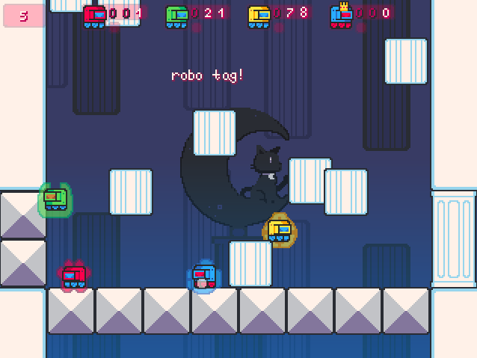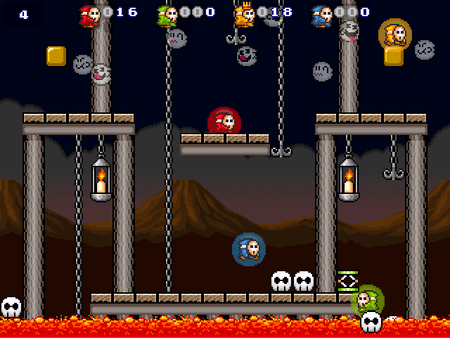
TYPE: Point Collection
DESCRIPTION: Robo Tag/Shy Guy Tag is similar to Tag, but instead of tagging players to transfer the It status, tagging players will turn them into robots/Shy Guys. When at least one player has been tagged, the other players slowly gain points, while the tagged players don’t.
There are several conditions that may happen if one is a robot/Shy Guy, besides not scoring points:
- They cannot use or store items in their inventory, so robots/Shy Guys are banned from using powerups.
- Robots/Shy Guys have a special property where they can resist taking any hits from DANGER tile types, and stage hazards (not counting crushing platforms and DEADLY or MILD DEADLY tiles)
- One Robot/Shy Guy contributes incrementations of 1 point each to the other players. Should there be two or three Robots/Shy Guys on screen, points gained will be doubled or tripled.
Should all players be transformed into a Robot/Shy Guy, they must wait a certain amount of time before they can become normal again. The first player to reach a certain amount of points becomes the winner.
Warning: Robo Tag/Shy Guy Tag has a bug in SMWar 1.8 Beta 2 where any point-incrementing items (1ups, 2ups, 3ups, 5ups) will cause the score to overflow, causing an insta-win in some cases. This bug has been fixed in SMWar 2.0 and Super Cat Wars.
SETTINGS:
- POINTS – Basic parameter. Sets the number of points between 50-1000 in intervals of fifty. When set to Unlimited, the game goes on endlessly.
- SPEED – Advanced parameter. Sets the speed of the Ghosts/Phantos, from Very Slow, Slow, Moderate, Fast, and Very Fast. In SMWar 2.0 and Super Cat Wars, two additional speed options are added: Extremely Fast and Insanely Fast, which probably don’t show you any fun at all.
- GHOST/PHANTO SLIDERS – Advanced parameter. Sets how many of a type of Ghost/Phanto to appear on screen after a player has picked up a Lamp/Key, with up to a maximum of five.
SUBSECTION 05.23 – Boxes Minigame
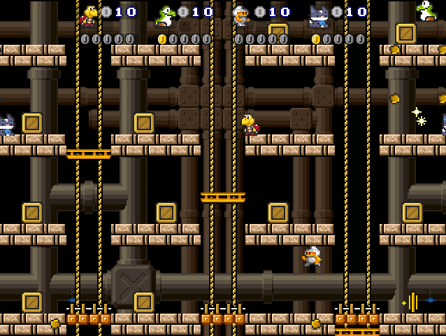TYPE: World Minigame/Items
DESCRIPTION: Boxes Minigame involves boxes, or crates, which are carryable map items that can be broken by tossing them. Some boxes contain a coin, which is required to win the game. A player can collect that coin, but it can also be stolen by other players who can get the coin, too. The goal of this minigame is to find all five coins hidden in different crates, or you could go for exhausting all players’ lives if you want.
Should a player find all the five coins, or defeat all players, they will be declared the winner.
SETTINGS:
Note: These settings are only adjustable in when editing a level containing this gamemode in the World Editor.
- LIVES – Basic parameter. Sets the number of points between 1-30 in intervals of one.
SUBSECTION 05.24 – Pipe Minigame
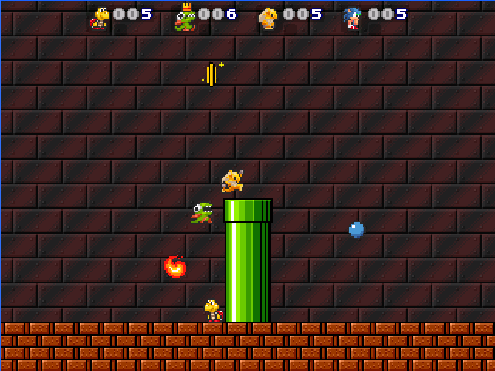TYPE: World Minigame/Items
DESCRIPTION: Pipe Minigame is similar to Coin Collection, but this time, coins and other items are ejected out of a single warp pipe. As usual, the players must collect coins to reach the target coin count and win. The following are items which can come out of the pipe:
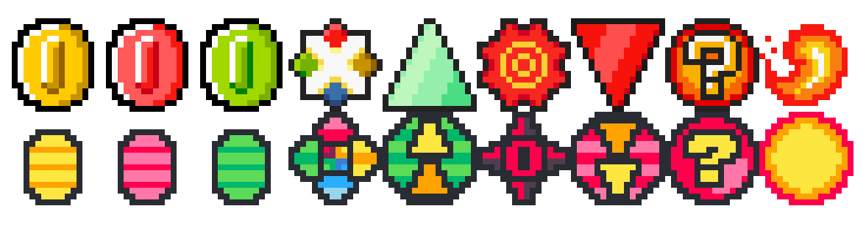
- YELLOW COIN – This adds 1 coin to the player’s coin count.
- RED COIN – These subtract 1 coin from the player’s count. Do not collect these!
- GREEN COIN – These add 5 coins to the player’s coin count, and play the 1up sound when collected. Rare!
- COLOR STAR – These items will increase coin spawn rate, but will transform all coins into team-colored coins that must be collected by a player matching the coin’s color. (eg. Player 1 can collect red coins, Player 2 can collect green coins, etc.)
- SPEEDUP BADGE – These items will increase the coin spawn rate.
- DARK STAR/BAD COIN STAR – Do not collect this item. This will cause a slew of bad red coins to fly out of the pipe.
- SLOWDOWN BADGE – These items will decrease the coin spawn rate, but they also lower the launching trajectory of all coins to make them easier to collect.
- ? BALL – This item will give a random effect based on the previous four items. You might be lucky enough to speed up the pipe spawn rate or be unlucky enough to cause a lot of bad red coins to spit out from the pipe.
- FIREBALL – This is not an item, simply touching this will instantly defeat you. Don’t touch it if you don’t want to be eliminated from the match for a temporary amount of time and get too far behind.
The first person to reach the target coin count wins.
SETTINGS:
Note: These settings are only adjustable in when editing a level containing this gamemode in the World Editor.
- POINTS – Basic parameter. Sets the number of points between 10-200 in intervals of ten.
SUBSECTION 05.25 – BOSS MINIGAME
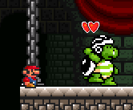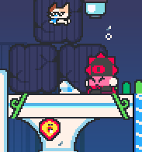
TYPE: World Minigame
DESCRIPTION: Boss Minigame pits the players against any of the three bosses, each with a different attack strategy and method of defeat. The three bosses are as follows:
DARK KALLIO / SLEDGE BRO (Hammer Boss)
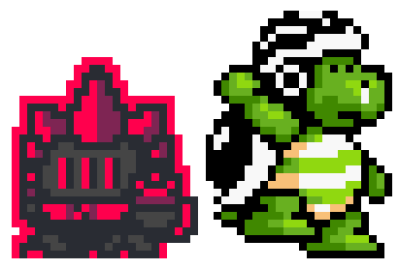
In Super Cat Wars, the Hammer boss is Dark Kallio, the main villain of Story Mode. In Super Mario War, the Hammer boss is a Sledge Bro from Super Mario Bros. 3. Technically speaking, this boss is 7 blocks high and his arena is about 12 blocks long.
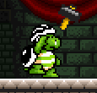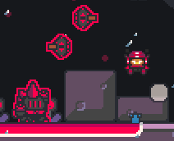
The Hammer Boss’ attack strategy is walking around and tossing his own hammer projectiles at the players. He can also jump and strike the ground, which triggers an earthquake that kills all players on the ground in a similar fashion to the effects of a Quake Bomb/POW Block.
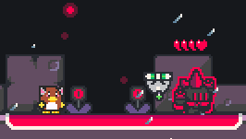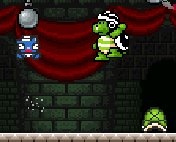
To defeat the Hammer Boss, players must defeat Tin Soldiers/Koopa Troopas and toss their shells at the Hammer Boss to deplete their health.
SWASHBUCKLER BABURU / BOMB BRO (Bomb Boss)
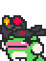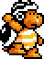
In Super Cat Wars, the Bomb boss is Swashbuckler Baburu. In Super Mario War, the Bomb boss is a Bomb Brother, a yellow Sledge Bro that throws bombs. Technically speaking, this boss is 7 blocks high and his arena is about 12 blocks long (14 in the Bomb Boss Game default arena).
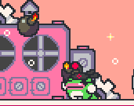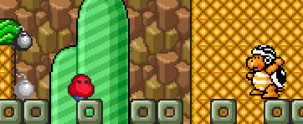
The Bomb Boss’ attack strategy is walking around and tossing bombs at the players. These bombs can explode and kill any player if not picked up. If the bombs are picked up, they will correspond to the player’s color and not hurt the owner, but it can still hurt other players like the bomb projectiles from a Bomb powerup.
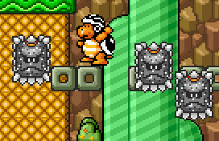
The Bomb Boss can also jump and strike the ground, which causes meteors/Thwomps to rain down on the arena, like their Survival counterparts.
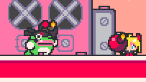
To defeat the Bomb Boss, players must hold and toss the bombs back at him to make them explode on him and deplete the boss’ HP.
STARGAZER LEONNE / FLAME BROTHER (Fire Boss)
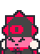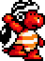
In Super Cat Wars, the Fire boss is Stargazer Leonne. In Super Mario War, the Fire boss is a Flame Brother, a red Sledge Bro that throws flying fireballs. Technically speaking, this boss is 5 blocks high and his arena is about 12 blocks long (16 in the Fire Boss Game default arena).
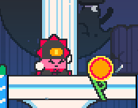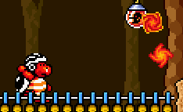
The Fire Boss’ attack strategy is walking around and shooting fireballs at the players. These fireballs fly in a straight path with a random direction and speed, and can wrap around the screen until they disappear.
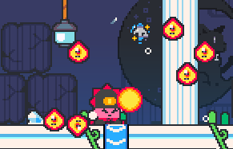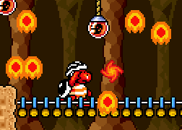
The Fire Boss can also jump and strike the ground, which causes Jumping Fireballs/Lava Bubbles to jump from the ground in a similar fashion to the Fireball/Lava Bubble powerup effects.
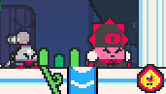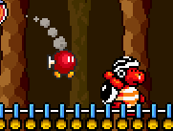
To defeat the Fire Boss, players must transform into a Kobolt Jr/Bob-omb and attempt to explode on her/him, which will deplete her/his HP. In order to do so, Frenzy bubbles/cards for the Kobolt Jr/Bob-omb appear around the map, which can be used to transform into such.
The first player to defeat the boss (any of these three) is declared the winner, but all players must remain on screen, or otherwise, a Game Over will occur and the players do not receive a win.
SETTINGS:
Note: These settings are only adjustable in when editing a level containing this gamemode in the World Editor.
- LIVES – Basic parameter. Sets the number of player lives between 1-30 in intervals of one.
- TYPE – Advanced parameter. Sets the boss type between Hammer, Bomb, or Fire. Note: This option does not work properly in SMWar 1.8 Beta 2 due to a bug. This bug has been fixed in SMWar 2.0 and Super Cat Wars.
- DIFFICULTY – Advanced parameter. Sets the difficulty of the boss between Very Easy, Easy, Moderate, Hard, and Very Hard. The harder the difficulty, the faster the boss will move and its attack strategies will become more erratic.
- HEALTH – Advanced parameter. Sets the health points of the boss from 1-20, in intervals of one.
SECTION 06 – Special Blocks
There are special blocks on the map which give the player items, serve as a means of help or hindrance, or can be used as projectiles.
STAR BLOCK (? BLOCK)
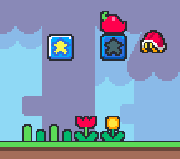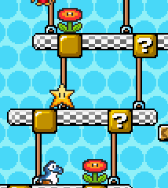
Hit this block to obtain a random powerup. It will be disabled for a set amount of time before activating again, which will give another powerup. Can be set in the Level Editor to define the probabilities of each powerup coming out of a block.
YELLOW STONE BLOCK (BRICK BLOCK)
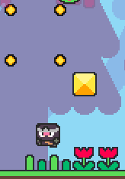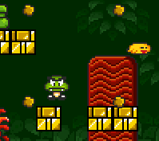
Hit this block to destroy it. If anything is standing on top of it, it will be harmed when the block is broken from below.
FALLING LOG (DONUT BLOCK)
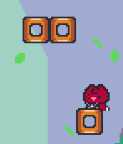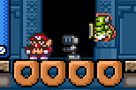
Standing on this block for too long will cause it to fall. Players can also crush other players using a falling log/donut block, as it is still solid while it is falling.
MUSHROOM BLOCK (NOTE BLOCK)
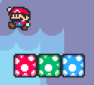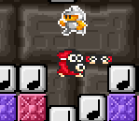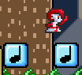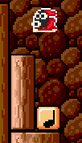
There are three types of mushroom blocks/note blocks, with all of them causing the player to bounce at regular intervals:
- GREEN Mushroom / WHITE Note Block allows the player to perform a high jump by holding UP.
- RED Mushroom / ORANGE Note Block allows the player to perform an even higher Super Jump by holding UP.
- BLUE Mushroom / BLUE Note Block allows the player to bounce… but they cannot perform a high jump. Too bad!
SCW has the option to turn on Colorblind mode, which gives indicator shapes to the blocks. Green Mushroom Blocks use a single-arrow, red ones use double-arrow, and blue ones use a circle.
VIEW BLOCK
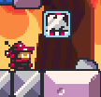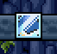
These blocks are made of glass and lets the player see what powerups are being cycled through the block. Time your hit to get the correct item!
These blocks share the same item properties as a regular ? Block/Star Block.
ROTATING BLOCK
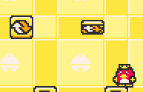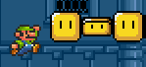
These blocks are denoted as yellow with spinning arrows in SCW, and yellow with eyes in SMWar. These flip for a short amount of time when hit, allowing players to pass through them. Hitting them with shells, tail/cape swipes, or a Ground Pound will cause them to break.
BOUNCE BLOCK
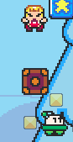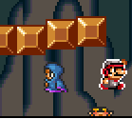
Not to be confused with the even bouncier Mushroom/Note Blocks. Bounce Blocks can be hit from below to strike players standing on top. These act like the platforms you can hit to flip enemies over in Mario Bros.
WEAPON BLOCKS
These are special blocks that require a weapon to be destroyed. From left to right:
- Ice Block / Fire Flower Block – Requires fireballs
- Cape Crate / Feather Block – Requires a Cape Spin from Olli’s Cloak/Cape Feather
- Blocky Turtle / Shell Block – Requires a hit from a shell
- Bomb Stone / Bomb Block – Requires explosions from a bomb projectile.
- Wooden Panel / Boomerang Block – Requires boomerangs
- Hard Bricks / Hammer Block – Requires hammers
- Dirt Block / Shoe Block – Requires a ground pound from the Rollerskates/Goomba’s Shoe or the Fake Moon Crystal/Tanooki Suit.
- Cloud Block / P-Wings Block – Requires Balloon/P-Wing flight to destroy.
- Cosmic Star / Super Star Block – Requires invincibility.
- Bushy Block / Leaf Block – Requires a Tail Spin from Tanuki’s Leaf/Super Leaf.
THROWABLE BLOCKS
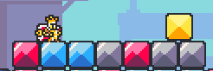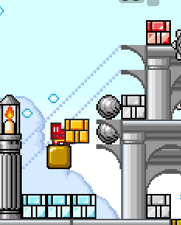
Toss these at a player or hit them with one while holding to hurt them. These will break immediately, but one type does not break! There are three types of throwable blocks, denoted by color:
- BLUE THROWABLE BLOCKS – These break when they hit a wall or one player/enemy.
- GREY THROWABLE BLOCKS – These act similar to the blue ones, but they can kill multiple players until it hits a wall.
- RED THROWABLE BLOCKS – The strongest of these blocks, they can kill multiple players AND bounce off walls, too.
SWITCH BLOCKS (ON-OFF SWITCH)
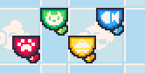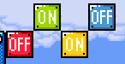
These switches are scattered all over the map. When switched ON, all Dotted-Line blocks become solid, and when switched OFF, all dotted-line blocks become transparent and pass-through. The switches match the color of their corresponding dotted-line blocks, and they come in four colors. Just like any other block, players can be killed from underneath by hitting the switch while players are standing on top of it.
DOTTED-LINE BLOCKS
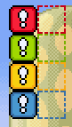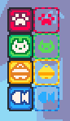
Note: Referred to as such even if solidified, like the ones in Super Mario Maker 2.
These blocks also come in four colors, and are assigned to each switch of the same color. In their “dotted-line” state (OFF), these blocks can be passed through, while in their “solid” state (ON), these blocks act as if were solid and cannot be passed through. Players can be crushed by Dotted-Line Blocks if they are inside some of them when a player turns on a switch and solidifies them.
In Super Cat Wars, all switches and Dotted-Line Blocks are designed to be colorblind-friendly, with their faces having team emblems that correspond to each color. Red = paw print, Green = cat face, Yellow = bell, and Blue = fish.
SECTION 07 – Stage Hazards & Gimmicks
There are various stage hazards and gimmicks that are scattered across the game map in SCW and SMWar. There are enemies that can spawn on their own, as well as moving obstacles, dangerous tiles, and others.
CANNONBALL / BULLET BILL
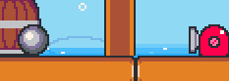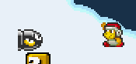
Type: Enemy Hazard
Cannonballs / Bullet Bills spawn at different speeds or directions, and are spawned from Cannonball / Bullet Bill spawners that are placed on different parts of the map. They can be stomped as normal, but colliding with them will still defeat you.
FIRE BAR
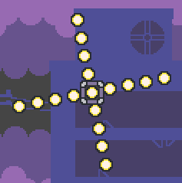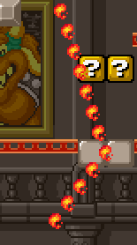
Type: Stage Hazard
Fire Bars are rotating bars of fireballs that cannot be defeated in anyway, rather they have to be avoided, as it can result in a kill unless invincible.
ELECTORB / ROTO-DISC
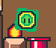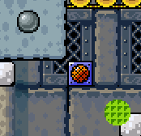
Type: Stage Hazard
Electorbs / Roto-Discs are nuclear waffles rotating electric orbs or flashing discs that can kill the player if touched. They can also be set to have multiple Roto-Discs or Electorbs in one path, in a similar fashion to Boo Buddies, which can be very dangerous to evade.
BURNER
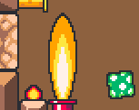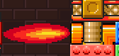
Type: Stage Hazard
Burners eject large flames that are three tiles long. These flames can harm players unless if they are invincible in any way.
MR. PRICKLES & BAMBOO BLOSSOM / PIRANHA PLANT
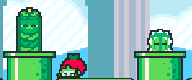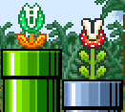
Type: Enemy Hazard
These enemies can come out of any tile in any set direction, preferably Warp Pipes, and are dangerous to touch. When they sprout from the ground, it’ll take a few seconds before they retreat. Mr. Prickles (Cactus) and Bamboo Blossom / Piranha Plants can be dispatched with projectiles to make them disappear for a bit before they come out to hurt the player again.
MONKEYS & FIRE PLANT MINIONS / FIRE PIRANHA PLANT
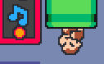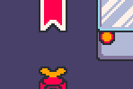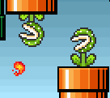
Type: Enemy Hazard
Notice: Fire plant minions are originally named “Vulcan Turnips” (conjectural) – the official current name is taken from the Neutronized Wiki which is sanctioned as official.
These enemies toss/spit fireballs at players that can hurt them. When they come out of the ground or Warp Pipe, they will seek out the first player in its radius and start to aim at them. Monkeys & fire plant minions / Fire Piranha Plants can also be dispatched with a Fireball for a short while.
MOVING PLATFORMS
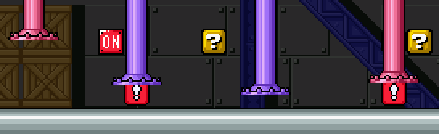
Type: Stage Gimmick / Stage Hazard
Depending on how they are used, moving platforms can send a player to another location and transport items lying around, or they can be used as crushers that can instantly kill players if they get caught between the ground and a moving platform. They can have three movement types: Continuous (wraps around the screen), Line Segment (Back and forth path), and Ellipse (Circular movement).
WARP PIPES
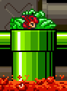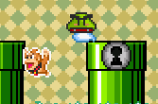
Type: Stage Gimmick
Various parts of the map include map warps, represented by Warp Pipes. Press a directional key in the direction of the warp pipe’s entrance to enter it and come out from another part of the map.
Notably, warps are handled with limitations on how the player can enter. The game may put lock symbols on pipes after a player enters, which prevents them from entering the pipe again. The locks can apply to entrances, exits, or both, depending on game settings.
SPIKES, LAVA, & OTHERS (HARMFUL TILE TYPES)
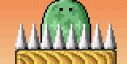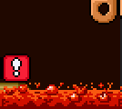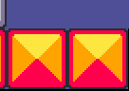
Type: Stage Hazard
Spikes & Lava are used to represent harmful tile types: DANGER, DEADLY, and MILD DEADLY.
- DANGER tile types are usually represented by spikes, and these can hurt the player unless if they are invincible.
- DEADLY tile types are usually represented by lava, and these can hurt the player AND subtract points regardless of if they are invincible or not. Items can also be consumed in these tile types.
- MILD DEADLY tile types act the same as deadly tiles but they do not take away points from the player. Most items (including carryable ones) can also pass through them unharmed.
These dangerous tile types may also be represented by miscellaneous hazards like laser beams, Spiky Fireballs (enemy), and flashing lava blocks. Be careful! These tile types can be viewed in the level editor.
SECTION 08 – Items & Powerups
The following section details items and powerups that appear throughout the game. These items may be used to shoot projectiles, create stage hazards, or just thrown at other players for easier defeat. Some items may be exclusive to certain game modes, which are classified into their own section.
There are various ways to obtain items:
- Hitting Star Blocks (? Blocks in SMWar) and View Blocks
- Item Bubbles (Item Cards) in Frenzy
- Item Shops (Toad Houses) in World Mode
- Treasure Chests in World Mode (These appear if a match is set to give items upon completion of the mode, and add items to your world inventory)
Items will disappear on their own if they hit a DEADLY tile type or get crushed by moving platforms. This also applies to map items.
Powerups and items are classified into the following:
- WEAPON – Denotes an item that lets you shoot projectiles (eg. Hammers or fireballs)
- STORED – Denotes items that are put into reserve boxes immediately after obtainment. Press the RESERVE button (default for P1 is LSHIFT) to use them.
- THROWABLE – Denotes items that can be thrown.
- COLLECTABLE – Denotes items that can have effects once collected.
- INSTANT – Denotes items that are used immediately.
- MAP ITEMS – Items that are part of the battle map. They act like throwable items but with special attributes.
- WORLD ITEMS – Items exclusive to World Mode.
Items listed here are named with their Super Cat Tales counterparts in Super Cat Wars, with their original SMWar names in parenthesis. Some SMWar names are updated to reflect the modern terms for the items used in more recent Super Mario games. Images show both SCW and SMWar versions of the item.
SORA FRUIT (MUSHROOM)
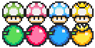
Type: INSTANT
There are four types of Sora Fruit/Mushroom, and they contribute extra lives, frags, enemy kills, points, etc. depending on the game mode. The more points they give the player upon attainment, the faster it moves.
- Green Sora Fruit/1up Mushroom grants 1 life / 10 points.
- Pink Sora Fruit/2up Mushroom grants 2 lives / 20 points, and moves faster than the previous fruit/mushroom.
- Blue Sora Fruit/3up Mushroom grants 3 lives / 30 points, and moves even faster than the previous fruit/mushroom.
- Golden Sora Fruit/5up Mushroom grants 5 lives / 50 points, and is the fastest of all the fruits/mushrooms.
POISON FRUIT (POISON MUSHROOM)

Type: INSTANT
This item will instantly defeat you if you collect it. If a player pushes another player into a Poison Fruit/Mushroom, it will count as a player kill and be classified as a Push Kill. Try using this item to your advantage!
SHUFFLE SCEPTER (MYSTERY MUSHROOM)

Type: INSTANT
Collecting this item will make all players swap positions on the map as well as stored items with each other. The switching is random, which means swapping with Player 2 one time and Player 3 the next is possible. You can get a kill by swapping your position with another player as you are about to hit a stage hazard.
CHILI PEPPER (FIRE FLOWER)

Type: WEAPON
This powerup lets you shoot fireballs that bounce across the map before hitting a wall or disappearing after some time. This weapon is also used to destroy Ice Blocks (Fire Flower Blocks). Depending on which way you’re facing, the fireballs will be shot in said direction. To shoot fireballs, press RUN (LCTRL for Player 1).
HAMMER
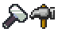
Type: WEAPON
The Hammer lets you toss projectile hammers with a varying trajectory arc depending on how fast the player is when shooting them. While this makes aiming a little more challenging, hammers can also be thrown through solid blocks and walls, too, making it easy for players to snipe a kill from a safe spot.
Hammers can be used to destroy Hard Bricks (Hammer Blocks).
BOOMERANG

Type: WEAPON
Boomerangs allow the players to toss boomerangs that fly in an arc, then turn around and fly backwards in a straight line. Like hammers, they can pass through walls. Boomerangs also have special trajectory settings which can be changed in Item Settings, which use their behavior from SMB3 and Zelda.
Boomerangs can also be used to destroy Wooden Panels (Boomerang Blocks).
OLLI’S CLOAK (CAPE FEATHER)
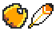
Type: WEAPON
This is a wearable powerup that allows players to don a yellow cape (or in SCW, use Olli’s Cloak). Players can jump in mid-air (two to five times, depending on settings), and can perform a Cape Spin to strike other players.
Cape Spins can also be used for hitting blocks from the side and flipping shells over. It can also destroy Cape Crates/Feather Blocks.
TANUKI’S LEAF (SUPER LEAF)

Type: WEAPON
In Super Cat Wars, Tanuki’s Leaf resembles the leaf that Tanuki holds in his official artwork in Yokai Dungeon.
Tanuki’s Leaf / Super Leaf allows the player to glide down slowly by mashing UP repeatedly. They gain Tanuki’s tail (Raccoon tail in Super Mario War) in the process, which also gives them the ability to perform a Tail Spin, similar to a Cape Spin. This item can also be used to destroy Bushy Blocks (Super Leaf Blocks).
BALLOON (P-WING)

Type: WEAPON (more described as COLLECTABLE)
Balloon (P-Wing) is not used like a weapon (it would be better referred to as a Collectable), although it is referred to as one in the original SMWar 1.8 Readme, and has a Weapon Block associated with it (Cloud Block / P-Wing Block). This item gives a player a balloon (or a pair of wings) to be able to hover for a small amount of time. To use the item, players must jump off the ground and hold UP in midair.
BOMB
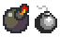
Type: WEAPON
This item allows players to create, hold, and toss bombs that create large explosions at other players. These bombs can also destroy Bomb Stone (Bomb Blocks).
Bombs created by players correspond to their team color. The owners of said bombs are immune to the explosions made by their own bombs, however players that do not match the bomb’s color will be defeated.
FREEZE POP (ICE WAND)

Type: WEAPON
A special powerup that allows players to blast a freezing spell at other players. This spell travels in a straight line, and when it hits a player, they will be frozen in a block of ice and be unable to move. Other players can touch the block of ice to destroy them and defeat the player, who is completely helpless.
Freezing spells correspond to the team color of the player that used the item. The owners of the Freeze Pop/Ice Wand are immune to the same-colored spells that they create.
GOLDEN CAT (SUPER STAR)

Type: COLLECTABLE
Golden Cat / Super Star is an item that bounces along the ground and grants invincibility to players that touch it. Collecting the Golden Cat / Super Star allows the player to become invincible for a short amount of time, allowing them to touch players, enemies, and stage hazards to instantly defeat them. Players are also impervious to DANGER tiles, yellow tile types that kill the player without being invincible (represented by spikes in actual maps), but cannot survive against DEADLY or MILD DEADLY tile types (represented by lava in actual maps), which instantly kill them regardless of invincibility.
When a player obtains the Golden Cat / Super Star, it plays a special song (Golden Cat from Super Cat Tales 1/Super Cat Tales: Magic Bridge! for SCW, and Invincibility (NES) from Super Mario Bros. for SMWar) and causes the player’s skin to flash different colors, which alerts other players that a player has become invincible using such item.
Golden Cat / Super Star allows players to destroy Cosmic Stars (Super Star Blocks) by simply touching said blocks.
KOBOLT JR. (BOB-OMB)
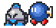
Type: COLLECTABLE
In Super Cat Wars, these explosive toys were invented by a certain scientist from a secret laboratory in the Sky Kingdom. Collecting a Kobolt Jr. toy or Bob-Omb will transform the player into a Kobolt Jr. (Bob-Omb in SMWar), and will create a large explosion that harms other players if the player presses TURBO while in such state.
Players can also steal this form by defeating a player while in the Kobolt Jr. / Bob-omb state, but the form can be lost entirely if they are also defeated in this form by a stage hazard, DANGER, DEADLY, and MILD DEADLY tile types.
FAKE MOON CRYSTAL (TANOOKI SUIT)

Type: COLLECTABLE
In SCW, there are fake Moon Crystals from a shady organization that do not really work like the genuine one, which is worn by Luna. With that said, the only power that these crystals can give is just temporary invisibility and invincibility (Don’t confuse these two words!).
Players using the Fake Moon Crystal / Tanooki Suit allow themselves to turn invisible / turn into a statue for a short amount of time, which also makes them impervious to most stage hazards, enemies, projectiles, and other players. However, this won’t protect them against DEADLY and MILD DEADLY tile types.
Players can also use the Fake Moon Crystal / Tanooki Suit to perform a ground pound, which can also destroy Dirt Blocks (Goomba’s Shoe Blocks) and hurt other players near them. To turn invisible/into a statue, press TURBO+DOWN, and to perform a ground pound, turn invisible/into a statue while in midair.
BIRD SWARM (BULLET BILL)
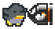
Type: STORED
Bird Swarm / Bullet Bill refers to a singular black bird / Bullet Bill which can be used as a stored item. Once this item is used, flying colored birds / Bullet Bills may come in from both sides of the screen, which can harm players that are not the same color/team as them. These enemies can also be stomped to dispatch them and gain extra height.
If two players activate a Bird Swarm / Bullet Bill, different-colored Bullet Bills/birds can collide into each other and create a large explosion, which can harm all players, making such situations more dangerous.
HOURGLASS (CLOCK)
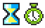
Type: STORED
An Hourglass/Clock is a stored item that can be used to slow down other players and reduce their jump height for a short amount of time. This allows the user in question to be able to catch up to other players to defeat them faster.
In Super Cat Wars, the Hourglass plays the Butterflies/Bonus theme from Super Cat Tales 1/Drop Wizard Tower, and in Super Mario War, the Clock plays a series of repeating notes from Super Mario Bros. 2.
QUAKE BOMB / POW BLOCK
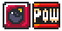
Type: STORED
This item, when used, shakes the screen and causes all players standing on a solid/semi-solid to be instantly defeated. This cannot harm players who are in mid-air.
THUNDER BOMB / mod BLOCK
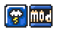
Type: STORED
This item is the opposite of a Quake Bomb / POW Block, where it defeats players in mid-air instead of players on the ground. In SCW, the Thunder Bomb’s appearance gives the implication that players in the mid-air would be struck by lightning (given that lightning scientifically has a higher chance to strike the highest point in the area).
FIREBALL / LAVA BUBBLE
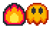
Type: STORED
Using a Fireball / Lava Bubble will cause a lot of Fireballs (Lava Bubbles or Podoboos in SMWar) to jump from the bottom, which can harm players if they are touched. Players can evade this attack by escaping to the higher parts of the map, which these enemies won’t reach.
TIN SOLDIERS & SHELLS / SHELLS (KOOPA, BUZZY BEETLE, SPINY)
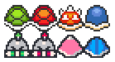
Type: THROWABLE
These shells can be tossed or kicked at other players to defeat them. Shells travel on the ground for an amount of time before disappearing, and rebound off walls and blocks. Depending on the type, these shells have different properties:
- Green Tin Soldier / Green Koopa Shell – The weakest type of shell. It can be defeated by projectiles, and once it hits a player or enemy, it is immediately defeated.
- Red Tin Soldier / Red Koopa Shell – This shell acts like the green counterpart, but it takes out more enemies and players than usual.
- Blue Beetle Shell / Buzzy Beetle Shell – This shell acts like the red shell/Tin Soldier, but it is impervious to projectiles.
- Wood Beetle Shell / Spiny Shell – This shell acts like its red counterpart, but it is dangerous to jump on because it has spikes on top. Ground pounding on this shell makes it flip over and be safe to jump on.
A multi-killing Shell will defeat a moving one-hit Shell if it tries to collide with each other, and the multi-killing Shell will continue to move across the screen. Otherwise, if these two types are the same, they will both be defeated. The shells’ speed can be changed depending on how fast the player is moving when they throw it, allowing for speedy combos.
Shells can also be stored in the item reserve. This happens if they are obtained in Frenzy Mode (depending on settings) and from the Bonus Wheel. Pressing RESERVE and TURBO will cause the player to instantly hold the shell after it is used in the item reserve, otherwise the player will just instantly kick it.
Blocky Turtles (Shell Blocks) can be defeated with any shell type in question.
BOUNCY MUSHROOM / TRAMPOLINE
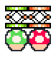
Type: MAP ITEMS
This item allows the player to bounce off it and perform higher jumps. By holding UP, they can do a super jump. Green ones let the player do a regular high jump, but red ones send the player even higher!
JELLOW / CARRYABLE SPIKE
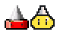
Type: MAP ITEMS
This item acts as a portable spike hazard that can hurt other players if they jump on it. NOTE that this item cannot protect you from being stomped.
ROLLERSKATES / GOOMBA’S SHOE
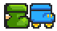
Type: MAP ITEMS
This item, while also holdable, can also act as a rideable item. Players using the shoe can perform ground pounds in midair that hurt other players, destroy Dirt Blocks (Goomba’s Shoe Blocks), and gain a weight boost that makes players able to bump opponents even farther than normal.
Repeatedly mashing LEFT & RIGHT allows players to exit the shoe.
SPIKY SHOE
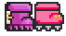
Type: MAP ITEMS
This item acts like the Rollerskates/Goomba’s Shoe, but a player riding it cannot move unless if they jump. The spikes on the bottom of the shoe makes it stuck to the ground.
Repeatedly mashing LEFT & RIGHT allows players to exit the shoe.
CRATE
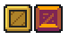
Type: MAP ITEMS
Some maps contain holdable crates that can be tossed to destroy them. Some crates may contain other items/powerups, and in the Boxes minigame, some crates contain a single coin.
MAGIC FLUTE (MUSIC BOX)
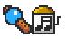
Type: WORLD ITEMS
For some reason, the Magic Flutes in Super Cat Wars do the opposite of the actual Magic Flute in Super Cat Tales 2 – they cause entities to fall asleep instead of waking up. (It’s more like the flute player’s flute in Ramal Town, used to put the Desert Spirits to rest)
A player can use the Magic Flute / Music Box to play a soothing melody on the World map, which causes all moving vehicles and enemies on the map to fall asleep. This prevents players from being forced into a match when they move over them, but the match can be played anyway if they enter on them like a normal level.
The music played with the Magic Flute / Music Box is the Magic Flute theme from Super Cat Tales 2 (extended version by Wowymolly) in Super Cat Wars, and the Music Box theme from the Super Mario All-Stars version of Super Mario Bros. 3 in Super Mario War.
CLOUD / LAKITU’S CLOUD

Type: WORLD ITEMS
This item can be used once to skip a level on the map. This is great for avoiding time-consuming matches and finding faster routes.
SWAP BADGE

Type: WORLD ITEMS
This item allows you to take control on the world map immediately when another player is in control.
WATCH (HOURGLASS)

Type: WORLD ITEMS
This will cause the entire world map to advance one turn. Vehicles will move around, and bridges may open or close.
REPLAY DISK (REPLAY BLOCK)

Type: WORLD ITEMS
If you wish to play levels that you have already beaten again, you can use a blue Replay Disk (Replay Block in SMWar) while standing on a completed level to activate it again. Shops can also be reactivated this way!
COLORED KEYS
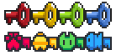
Type: WORLD ITEMS
There are four colored keys that are designated to a specific-colored door on the world map. When a key is used on a door, it is immediately consumed. The player must stand in front of a locked door and use the Key to open it.
SCORE COINS
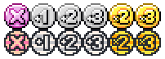
Type: WORLD ITEMS
There are special Score Coins that will negate, add, or multiply the point value for the next level. Using other Score Coins while a Score Coin is in effect will cancel its current effects out.
- X COIN – X Coins negate a point value for the level.
- +2 COIN – +2 Coins add two to the current point value for the level.
- +3 COIN – +3 Coins add two to the current point value for the level.
- x2 COIN – x2 Coins double the current point value for the level.
- x3 COIN – x3 Coins triple the current point value for the level.
EXTRA POINTS / 1-10 GREEN SPHERES
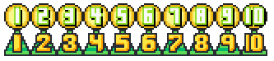
Type: WORLD ITEMS
These items can be obtained from Shops / Toad Houses only, and can be used to add 1-10 points to your total point counter.
MINUS POINTS / 1-10 RED SPHERES
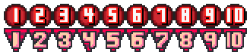
Type: WORLD ITEMS
These can also be obtained from Shops / Toad Houses only, but they can subtract 1-10 points from your total point counter. They ARE not really good, so avoid collecting these!
SUBSECTION 08.1 – Secret Orbs
These secret orbs add special effects to the match once certain conditions are met to obtain them. These can be disabled in the Gameplay Options menu (in SMWar 2.0 and Super Cat Wars only) if these orbs are annoying players in gameplay.
SECRET ORBS
ORB OF TEMPEST / Red Wind Orb
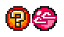
Type: ??????
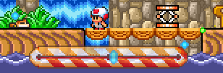
In SCW, this is a strange red magic orb found within the windy mountains below Sky Kingdom. This will cause the wind feature to be enabled, causing wind to be blown across the screen, marked by colorful particles flying in the air. The wind blows players on the arena, but does not affect anything else like map items, powerups, enemies, and others.
The wind meter shows how strong the wind is blowing in a specific direction. If the cursor leans towards either edge, the wind may be very strong when blowing either left or right. If the cursor leans towards the center, the wind may be very weak. The speed of the wind is also determined by the speed of the particles floating in the air, not to be confused with the snow/leaves eyecandy.
To unlock this orb, two players must get two consecutive in-air kills, and break five Yellow Stone Blocks/Brick Blocks. The effects of this powerup are permanent for the rest of the match.
ORB OF DISORIENTATION / Green Dizzy Orb

Type: ??????
Warning: The effects can cause actual dizziness and nausea (and possible epilepsy). It’s best that you turn Secrets off in Gameplay Options to avoid this.
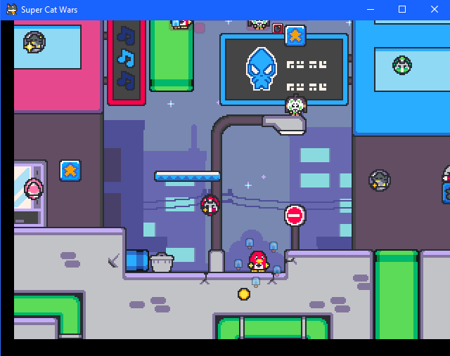
In SCW, this magic orb is said to mislead others into a cloud of dizziness and hallucination, and can only be found as a strange treasure in the Ancient Pyramid.
The Green Dizzy Orb, known as the Orb of Disorientation in Super Cat Wars, causes the screen to move around in an erratic manner, distracting the players’ vision.
To unlock this orb, freeze and defeat five players with the Freeze Pop/Ice Wand. The effects of this orb are permanent for current match like with the first orb.
ORB OF MISDIRECTION / Yellow Moonwalk Orb

Type: ??????
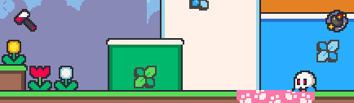
Note: Skull is walking backwards to the right.
In SCW, this magic orb is said to control and mess up the movements of anyone who uses this orb, and can be found within a secret chamber in the Ancient Temple.
The Moonwalk Orb causes all players to walk backwards. As a result, projectiles may also be launched backwards, as well as carried items, making it harder for players to hit others with projectiles.
To unlock this orb, throw fireballs with the Chili Pepper/Fire Flower nine times, then jump on a Mushroom/Note Block five times. The effects of this orb are permanent for the rest of the match, as with other effects.
ORB OF DARKNESS / Blue Spotlight Orb

Type: ??????
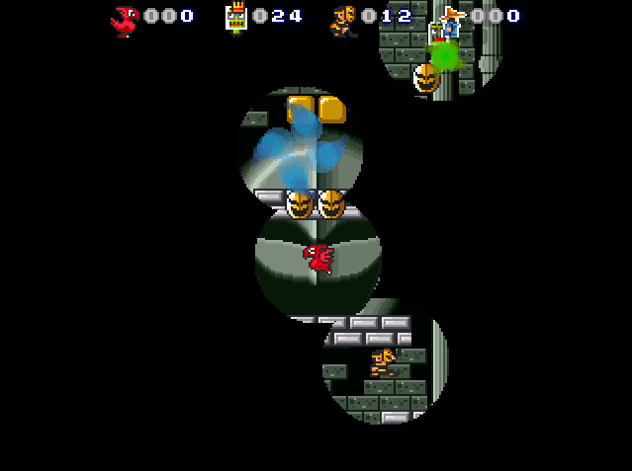
Don’t forget. I’m with you in the dark……… : )
In Super Cat Wars, this is a very elusive magical orb found within the darkest chasms of the Nugget Canyon caverns. The Orb of Darkness/Blue Spotlight Orb causes the entire arena to be shrouded in darkness, with players and projectiles acting as the only light source.
To obtain this secret orb, press “LEFT-RIGHT-LEFT-RIGHT-UP-UP” three times… very fast. Don’t do this, though, if you don’t want to actually risk your hands getting hurt.
As with the previous three orbs, the Spotlight Orb’s effects are permanent until the match ends in any way.
SUBSECTION 08.2 – Mode-exclusive Items
The following lists items that are exclusive to specific game modes. This does not include mode objects (like bells and flags).
EXTRA TIME
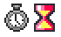
Type: INSTANT Modes: TIME LIMIT, BELL (STAR)
This clock adds more seconds to the timer in Time Limit and Bell / Star modes.
HEART

Type: INSTANT Modes: HEALTH
This heart adds an extra half-heart to your health bar in Health Mode, allowing you to endure more hits from other players and hazards.
JAIL KEY
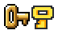
Type: STORED Modes: JAIL
If you are trapped in a jail cage (which slows you down and reduces jump height), you can collect a Jail Key to free yourself instantly.
EXTRA COIN
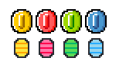
Type: INSTANT Modes: COIN COLLECTION, GREED
Sometimes, extra coins can pop out of Star Blocks / ? Blocks. You can collect them just like any normal coin, and there are extra types found in Greed only:
- Yellow Coin – 5 coins
- Red Coin – 10 coins
- Green Coin – 15 coins
- Blue Coin – 20 coins
COLOR STAR

Type: INSTANT Modes: PIPE MINIGAME
In Pipe Minigame, this will turn all coins into colored ones that can only be collected if your team color matches the color of the coin (example: blue coins can be collected by Blue Team, red coins can be collected by Red Team). This will also increase the coin spawn rate.
SPEEDUP BADGE

Type: INSTANT Modes: PIPE MINIGAME
In Pipe Minigame, this will speed up the spawn rate of coins and fireballs for a temporary amount of time. No other powerups will spawn from the pipe during the effects of this badge.
DARK STAR / BAD COIN STAR
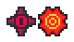
Type: INSTANT Modes: PIPE MINIGAME
Do not collect this item! This item will cause the pipe to spawn a lot of red coins at a very fast rate. These red coins can deplete the player’s coin count.
SLOWDOWN BADGE

Type: INSTANT Modes: PIPE MINIGAME
In Pipe Minigame, this will slow down the coin spawn rate and cause the launch trajectory to be smaller for easier collecting. No other powerups will spawn from the pipe during the effects of this badge.
? BALL

Type: INSTANT Modes: PIPE MINIGAME
An item in Pipe Minigame that activates a random effect from the previous four powerups.
SECTION 09 – Game Options
To access game options, select Options on the main menu.
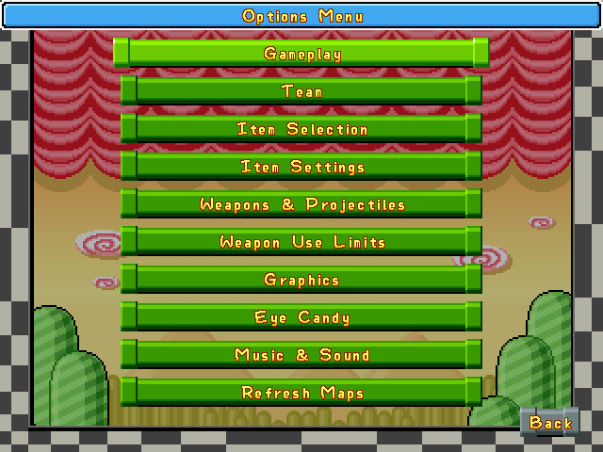
You’ll be greeted with the following categories pertaining to specific options:
- GAMEPLAY – Options to change some important aspects of gameplay.
- TEAM – Select this to change team mechanics.
- ITEM SELECTION – Changes how often each item spawns in the game, and includes item sets based on which items spawn in their origin Mario games.
- ITEM SETTINGS – Changes settings related to usage and spawning of items and the Bonus Wheel.
- WEAPONS & PROJECTILES – Options pertaining to how weapons and projectiles work, including item life, feather jumps, freeze duration, etc.
- WEAPON USE LIMITS – This section contains options to set how many times a weapon can be used before it wears off the player.
- GRAPHICS – Changes the graphics packs, framerate limit, and the draw layer system.
- EYECANDY – Changes specific graphics for effects, score notices, spawn animations, and other things.
- MUSIC & SOUND – Change music and sound volumes, sound packs, music packs, and the announcer.
- REFRESH MAPS – Simply an option to refresh map thumbnails. This will cause the game to stop responding for a while as it creates new map thumbnails.
SUBSECTION 09.1 – GAMEPLAY SETTINGS
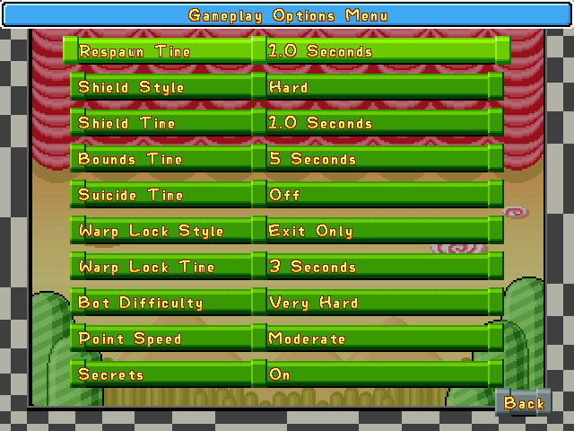
- RESPAWN TIME – Sets the time it takes for the player to respawn upon death. Value can be set between 0 (instant) and 10 seconds, in increments of 0.5 seconds.
- SHIELD STYLE – Sets the type of shield. No Shield passes through players, Soft passes through players, Soft with Stomp passes through players but you can stomp them, and Hard shield restricts passing through players although you can stomp on them.
- SHIELD TIME – Changes the amount of time you are invincible after respawning or warping. Value can be set between 0 (instant) and 5 seconds in increments of 0.5 seconds.
- BOUNDS TIME – Staying at the top of the screen for too long in an attempt to camp from other players’ attacks will penalize you with dying. The amount of time allowed before dying can be set from 1 to 10 seconds in increments of 1 second. Set it to Infinite to disable this option altogether.
- SUICIDE TIME – Players who stay still for too long will be penalized by dying. The amount of time allowed for the player to stay still before dying can be set to 3, 5, 8, 10, 15, and 20 seconds, or disabled altogether.
- WARP LOCK STYLE – Sets how warps behave during the match. Entire Connection locks all warps that share the same number in the level editor. All Warps locks all warps, regardless of number. Entrance Only locks the warp that the player has entered. Exit Only prevents the warp exit from being used. Entrance and Exit locks the entrance and exit that the player used.
- WARP LOCK TIME – Warp lock duration can be set between a value of 1 to 10 seconds in increments of 1 second, or can be set to Off. When set to Off, warps do not lock after use.
- BOT DIFFICULTY – Sets the difficulty level of the AI: Very Easy, Easy, Moderate, Hard, and Very Hard. Note that the AI may not be smart sometimes, and may run into lava or hazards.
- POINT SPEED – Sets how fast players gain or lose points in point-based modes like Domination or Tag. The speed can be set to Very Slow, Slow, Moderate, Fast, or Very Fasts.
- SECRETS – Toggles the Secret Orbs feature from 1.8 Beta 2. If set to ON, the secret orbs will spawn under the correct conditions. (For ways to activate the secret orbs, check the Secrets section). This is especially used for accessibility.
SUBSECTION 09.2 – TEAM SETTINGS
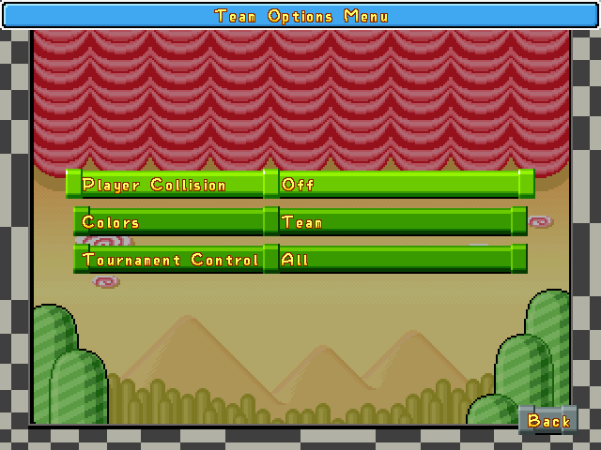
- PLAYER COLLISION – Sets how player collisions work in a team. Off makes all teammates and projectiles pass through each other (does not apply to Shells/throwable blocks). Assist makes teammates jump off each other by holding JUMP, allowing for teamwork. On enables friendly fire, so you can hurt your teammates.
- COLORS – Set this to Team to make all teammates be of the same color. Set this to Individual to make individual players different colors. (P1 = red, P2 = green, P3 = yellow, P4 = blue)
- TOURNAMENT CONTROLS – Changes which teams or players are in control of the tournament after playing a single game.
SUBSECTION 09.3 – ITEM SELECTION SETTINGS
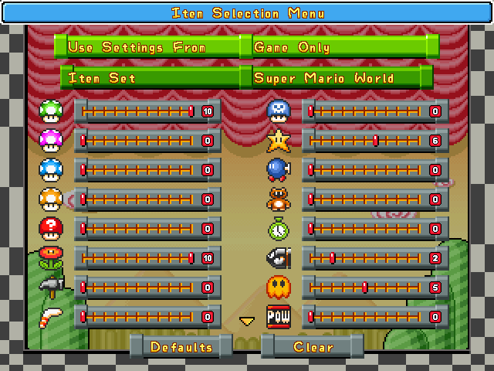
26 sliders correspond to one of the different items that can appear from a Star Block (? Block), as well as the relative frequency of that one popping out. The sliders can be set from 0-10, with 0 meaning that the item does not appear at all, and higher numbers indicate a higher chance.
- USE SETTINGS FROM – Item weights are selected from either the maps, game settings, a basic average of the two, or weighted average of the two.
- ITEM SET – Lets you choose preset powerup weights.
  - Balanced Set is the game’s recommended balanced set.
  - Weapons Only sets the game to spawn weapons only.
  - Koopa Bros Weapons sets the game to use weapons that are associated with Hammer Bros., Boomerang Bros., and Fire Bros.
  - Support Items focuses more on items that affect the player’s status and score.
  - Booms and Shakes focuses on items that perform explosions and POW quakes.
  - Fly and Glide focuses on items that allow the player to fly around the map. Fake Moon Crystal / Tanooki Suit is included as it was once a flying item like the Super Leaf in SMB3.
  - Shells Only is well… what it says.
  - Mushrooms Only sets items to Mushroom-related items. This also includes the Shuffle Scepter in Super Cat Wars as it is a Mystery Mushroom reskin.
  - Super Mario Bros. 1 – Only chooses items that appear in Super Mario Bros.
  - Super Mario Bros. 2 – Only chooses items that appear in Super Mario Bros. 2.
  - Super Mario Bros. 3 – Only chooses items that appear in Super Mario Bros. 3.
  - Super Mario World – Only chooses items that appear in Super Mario World.
Click Defaults to set the item sliders back to their original configuration. Click Clear to clear all configurations.
SUBSECTION 09.4 – ITEM SETTINGS
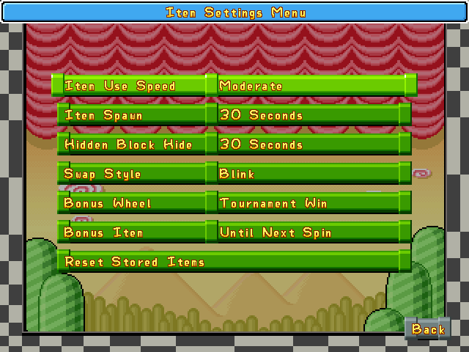
- ITEM USE SPEED – Sets the time it takes between pressing Use Item and using an item in your reserve box. It can be set from Very Slow (2 seconds), Slow, Moderate, Fast, and Very Fast (Less than half of a second)
- ITEM SPAWN – Sets how much time it takes for a Star Block / ? Block to activate after an item is spawned from it. It can be set from 5 to 60 seconds in increments of 5, and if set to off, disables said item block completely.
- HIDDEN BLOCK HIDE – Sets how much time it takes for a hidden block to disappear after an item has been spawned from it. It can be set from 5 to 60 seconds in increments of 5, and if set to off, disables said hidden block completely.
- SWAP STYLE – Sets the swapping visuals of the Shuffle Scepter / Mystery Mushroom. Blink makes the players’ new positions blink for a few seconds before returning to normal play, Instant swaps players in an instant (not recommended), and Walk makes the players walk to their new positions before resuming play.
- BONUS WHEEL – Sets when will the Bonus Wheel appear. Tournament Win sets the Bonus Wheel to appear after a tournament win, Every Game sets the Bonus Wheel to appear after a game has ended, and Off disables it entirely.
- BONUS ITEM – Sets if the item obtained from a Bonus Wheel remains with the player for the rest of the game or until the next spin of the Bonus Wheel.
- RESET STORED ITEMS – Click this to remove all items stored in the reserve box.
SUBSECTION 09.5 – WEAPONS & PROJECTILES SETTINGS
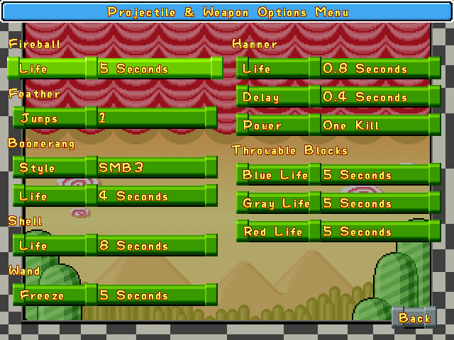
- FIREBALL LIFE – Sets how long the fireballs should last when thrown. Can be set from 1-10 seconds (5 is default)
- FEATHER/CLOAK JUMPS – Sets how many times the player can jump with Olli’s Cloak / Cape Feather. Can be set between 1-5 (1 is default)
- BOOMERANG STYLE – Sets the style of trajectory.
  - Flat style makes the boomerangs travel straight forward until they hit the edge of the screen, after which they "bounce" back and travel straight towards the other edge of the screen.
  - SMB3 style makes the boomerangs travel in a long forward arc before turning around and coming back in a straight line.
  - Zelda style makes the boomerangs travel straight forward for a short distance before turning around and seeking out the player that shot them.
- BOOMERANG LIFE – Sets the boomerang life from 1-10 seconds (4 is default).
- SHELL LIFE – Sets how long shells last before they disappear. It can be set to 1-10, then 15, 20, 25, or 30 seconds. Set this to Unlimited to make the shells last forever.
- WAND FREEZE – Changes how long players are frozen with the Ice Wand blast. It can be set to 1-10, then 12, 15, 18, or 20 seconds.
- HAMMER LIFE – Sets how long hammers last between 0.5 and 1.2 seconds, in increments of 0.1 second. Set this to No Limit to make hammers disappear at the bottom of the screen.
- HAMMER POWER – One Kill causes the hammer to disappear once it hits a single player or enemy. Multiple Kills causes hammers to go right through everything they touch.
- THROWABLE BLOCKS LIFE – The amount of time for throwable blocks to live can be set to 1-10 then 15, 20, 25, and 30 seconds. This can also affect how much you can hold these blocks before they disappear in your hands. Set this to Unlimited to make them live forever.
SUBSECTION 09.6 – WEAPONS USE LIMITS SETTINGS
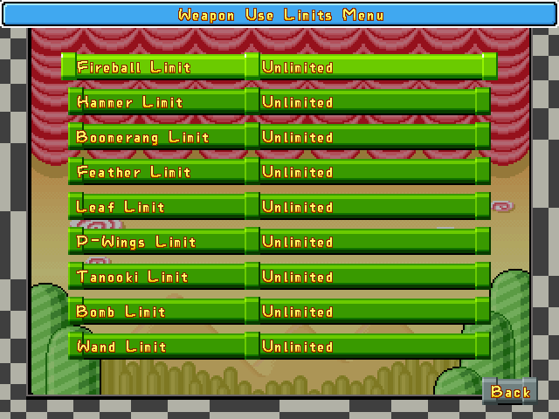
Each weapon has a Use Limit which can be changed in this section. The default is Unlimited, which makes them last forever, but the player can change this to 2, 5, 8, 10, 12, 15, 20, 25, 30, 40, or 50 uses. Once the number of uses is used up, the item wears off from the player.
- For projectile-based items like Chili Pepper/Fire Flowers, hammers, boomerangs, Freeze Pop/Ice Wand, and bomb, each spawn of a projectile is 1 use. Failing to catch boomerangs will count as 1 extra use.
- For flight-based items like Olli’s Cloak/Cape Feather, Tanuki’s Leaf/Super Leaf, Balloon/P-Wings, one jump, glide, or period of flight costs 1 use. Performing a spin attack with the cape/tail will also count as 1 use.
- For the Fake Moon Crystal/Tanooki Suit, each transformation into a statue will count as one use.
SUBSECTION 09.7 – GRAPHICS SETTINGS
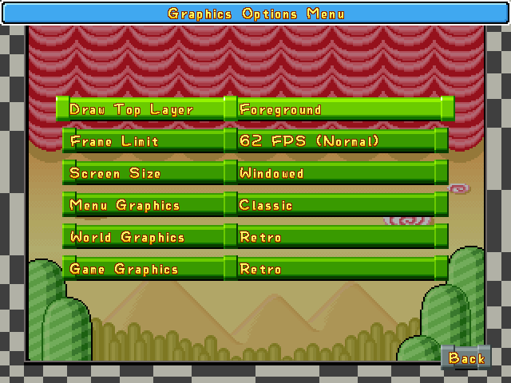
- DRAW TOP LAYER – There are tiles under the Foreground layer in map’s data that cause players, enemies, and special blocks to be drawn behind these tiles. Setting this to Foreground will do exactly as described before.
- FRAME LIMIT – Sets the speed at which the game runs. It can be set to 10, 15, 20, 25, 30, 35, 40, 45, 50, 55, 62 (DEFAULT, NORMAL), 66, 71, 77, 83, 90, 100, 11, 125, 142, 166, 200, 250, 333, 500, and NO LIMIT. If the game plays too slow for you, change this option.
- SCREEN SIZE – Sets the game to be played in fullscreen and windowed modes.
- MENU, WORLD, GAME GRAPHICS – Sets the game to use a custom graphics pack if you have any installed. In Super Cat Wars, use this option to change the color of user interfaces and menu (these are installed as Blue Theme, Yellow Theme, and Green Theme). Classic is default.
SUBSECTION 09.8 – EYECANDY SETTINGS
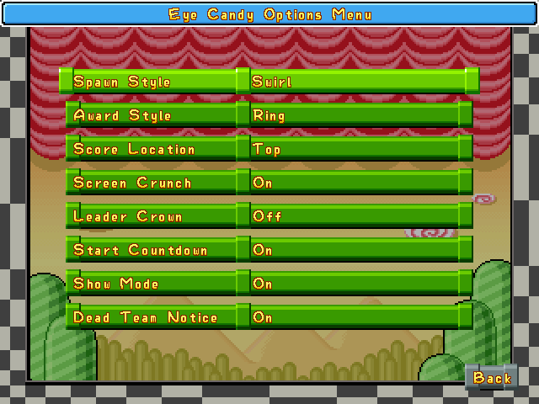
- SPAWN STYLE – Sets the spawn animation for players. Swirl makes players appear in a swirling smoke animation. Door makes players appear from exiting a colored door. Instant makes players appear instantly without extra animations.
- AWARD STYLE – Sets the eyecandy for if the player gets 3 or more consecutive kills without dying.
  - Fireworks causes basic eyecandy to shoot out of the player, like a fireworks display.
  - Spiral causes basic eyecandy to spiral out from the player.
  - Ring causes small icons to circle the player. These icons represent the last 10 kill types (so, for example, when you hit someone with a fireball, you will receive a Chili Pepper/Fire Flower icon). When the player is killed, these icons will scatter.
  - Souls causes nothing to be displayed until the player's chain of kills is broken, after which several icons will fly out of the dead player, representing the souls of the players he killed.
  - Text causes a simple text indicator to pop out of the player. (This is also the only option which gives an award for only 2 consecutive kills.)
  - None disables all effects.
- SCORE LOCATION – Changes where the scores are displayed on the screen. Top displays the scores on top of the screen, Bottom displays the scores at the bottom, and Corners display the scores for each player on all four corners.
- SCREEN CRUNCH – Turning this on will cause the screen to “crunch” every time someone dies.
- LEADER CROWN – Toggles the crown on the leading player in game. When set to Off, the crown is displayed on the scoreboard only.
- START COUNTDOWN – Displays a 3-2-1-GO! countdown at the start of the match before players spawn onto the map. Spawning is immediate if turned off.
- SHOW MODE – Displays the type of mode being played at the start of the match. If set to OFF, the mode is displayed only on the Single Game Menu and on the Pause Screen.
- DEAD TEAM NOTICE – Shows a brief message upon team elimination. A sound effect will play to accompany this: in SCW, the three Lost Yeti game over sounds are played if any teams are eliminated, but in SMWar, the Super Mario World pipe sound is played instead.
SUBSECTION 09.9 – MUSIC & SOUND SETTINGS
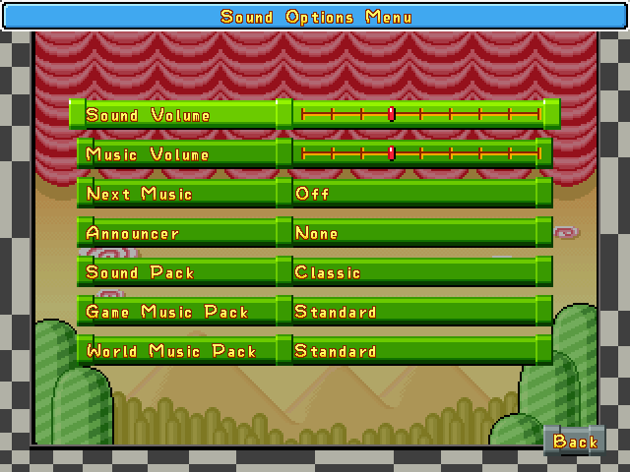
- VOLUME – Change the volume of the sound effects and music. The volume bars for each are separate.
- NEXT MUSIC – If set to OFF, the current music will loop indefinitely until it is changed by pressing TAB during gameplay. If set to ON, the game will cycle through a list of music in its set category for the map, with each track playing once.
- ANNOUNCER – Toggles the announcer sounds. This applies to combo sounds, countdown sounds, consecutive kill interruptions, and game start sounds.
- SOUND PACK – Select a custom soundpack if installed. This will change all sound effects that play in the game.
- MUSIC PACKS – Change the music that plays during matches, the main menu (Game Music Pack) and in world maps (World Music Pack). This also affects victory and tournament victory themes.
  - Super Mario War contains the Standard music pack for Game Music Packs, which plays tunes from the All-Stars versions of SMB3 and SMB2. In SMWar 2.0, the music pack is also now bundled with music from SMB1, as well as new SNES rearrangements of the new SMB and SMB3 music from Super Mario Maker 1 and 2.
  - Super Cat Wars contains five music packs: Classic (SCT) (all music from SCT1 and SCT2 as well as future games in the series), Drop Wizard (all music in Drop Wizard and Drop Wizard Tower), Neutronized Jams (music from various Neutronized games including Slime Pizza, Mineblast!!, Picnic Penguin, Yokai Dungeon, and more), ThomasYoung Jams (music from various Thomas K. Young games including Dadish, Dadish 2, and Super Fowlst 2), and Jack the Ripper (OST composed by Rakugaki-otoko (DREAMSBELL) for his own game, Jack the Ripper).
SECTION 10 – Community Links
Here is a list of community links related to Super Mario War and Super Cat Wars:

DISCORD SERVERS for Super Mario War / Super Cat Wars:
NOTE: In accordance with Discord Terms of Service, you must be at least 13 years old or older to join Discord.
Super Mario War 72dpiarmy Discord Server (Official Discord server for SMWar): https://discord.gg/Sphjw7r
Super Cat Wars Community Server (Official Discord server for SCW): https://discord.gg/esC6dH2


SUPER MARIO WAR MODDING COMMUNITY: https://gamebanana.com/games/6265


SUPER CAT WARS ON GAMEJOLT:
https://gamejolt.com/games/supercatwars/627452

SMWSTUFF Reloaded
At this moment, you can get SMW 1.8 Beta 2, or play it in the browser, or download thousands of skins and hundreds of maps.
LINK: http://smwstuff.net

SMWar 2.0 by mmatyas
The source code for the SMWar fork by mmatyas can be found at:
https://github.com/mmatyas/supermariowar

72dpiarmy (SuperSanctuary) Forums
Super Mario War 1.8 Beta 2: http://72dpiarmy.supersanctuary.net/index.php?topic=10241.0
Super Cat Wars: http://72dpiarmy.supersanctuary.net/index.php?topic=11250.0

SCW Official YouTube Channel (OST, development updates, etc.)
EleCyon: https://www.youtube.com/channel/UC7TttyT2PqcBXqNrZT28Q8A

SECTION 11 – Frequently Asked Questions
Q: My antivirus thinks the game, the server client, or its level & world editors are suspicious files/malicious software!
A: This is especially important for users of antiviruses like Avast Antivirus. This is called a “false positive”, in which the software is detected as malicious or suspicious even though it is genuine and safe to run. Please do not panic. If your antivirus keeps deleting or scanning such files again, you may add an exception to them.
Q: My tilesets and graphics packs do not display properly! My map thumbnails do not load properly! How can I fix them?
A: Tilesets should be in 24-bit PNG, and are at a maximum of 512x512 (1024x1024 for large tiles, 256x256 for small tile sheets). All graphics should be at the correct resolution or original size as the Classic graphics to display properly, and be in 24-bit PNG. Please see Section 1 of the SCW SMWar Customization Guide for more information.
Q: My backgrounds list in the level editor and the backgrounds in-game are glitching out and displaying black spaces!
A: All backgrounds are recommended to be in 24-bit PNG format, and are at 640x480 resolution, designed to fit an entire battle map. Make sure they are in these formats.
Q: My skins do not appear!
A: Make sure the skins are at the correct size: 192x32 (2x, complete), and must have all six frames filled in (32x32 or 16x16 each). They must also be in 24-bit BMP format for the game to show them properly.
Q: The game crashes upon starting a match or starting up in general.
A: Do not delete any files in the gfx/packs/Classic folder, as some files are required for the game to run, otherwise it will crash (ex. Land_Classic.png). Make sure your game folder is complete, too. If the game loads any graphics that contain transparent pixels, there’s a chance it could crash attempting to load those.
Q: My game is checking for a missing DLL file: MSVCR71.dll, and won’t start! (Legacy versions only)
A: Check this article: https://techcommunity.microsoft.com/t5/iis-support-blog/msvcr71-dll-is-missing/ba-p/1074724, or download the file from here: https://www.dll-files.com/msvcr71.dll.html and place it in your System directory (follow the instructions in the linked FAQ). Then attempt to run the game again. This file is no longer required in SMWar 2.0 and Super Cat Wars, so it is recommended to download SMWar 2.0 instead.
Q: I found a bug!
A: If you are playing on SMWar 1.8 Beta 2, chances are the bug may be already fixed in mmatyas’ build of SMWar (SMWar 2.0) and Super Cat Wars (based on SMWar 2.0). Otherwise, if there are bugs happening on SMWar 2.0 and Super Cat Wars, don’t hesitate to report them in the GitHub repository or the Discord servers, listed above. You can also find bugs by checking the logs in the Command Prompt that accompanies the game for errors.
Q: Audio does not play properly, or sound options are disabled.
A: Check your sound drivers and sound card, chances are they may need to be updated or serviced properly. Make sure the volume isn’t muted, set your sliders for sound and music up if possible, as well as the master volume on your Windows computer. Make sure to check your speakers as well if they are turned down.

THANK YOU FOR READING
Thank you for reading the base game guide! We, from EleCyon & 72dpiarmy’s community, hope that you can enjoy Super Mario War & Super Cat Wars at your own pace.
For Level Editor documentation, please see “SCW SMWar Level Editor Guide.docx”.
For World Editor documentation, please see “SCW SMWar World Editor Guide.docx”.
For customization documentation, please see “SCW SMWar Customization Guide.docx”.

